PSPTIS100 Apply codes and standards to professional judgement
Release: 1

PSPTIS100 Apply codes and standards to professional judgement

Modification History
Release | Comments
1 | This unit was released in PSP Public Sector Training Package release 1.0 and meets the Standards for Training Packages.  This unit supersedes and is equivalent to PSPTIS603A Apply codes and standards to professional judgement.  - Unit code updated  - Content and formatting updated to comply with the new standards  - All PC transitioned from passive to active voice

Application
This unit describes the skills required to apply current and relevant standards of professional and ethical behaviour by translators and interpreters in complex settings and interactions. The unit requires knowledge of professional codes of ethics and the development and maintenance of professional judgement. It requires the ability to consider a wide range of professional issues and to reflect on and continuously develop a highly informed approach to practice.
This unit applies to those working as translators and interpreters in a range of complex or specialised settings and contexts.
The skills and knowledge described in this unit must be applied within the legislative, regulatory and policy environment in which they are carried out. Organisational policies and procedures must be consulted and industry codes and standards for ethical translating and interpreting adhered to.
Those undertaking this unit would work independently using support resources as required, while performing complex tasks in a range of specialised contexts.
No licensing, legislative or certification requirements apply to unit at the time of publication.

Competency Field
Translating and interpreting

Elements and Performance Criteria
ELEMENTS | PERFORMANCE CRITERIA
Elements describe the essential outcomes | Performance criteria describe the performance needed to demonstrate achievement of the element. Where bold italicised text is used, further information is detailed in the range of conditions section.
1. Research ethical and professional issues | 1.1 Maintain detailed knowledge of ethical and professional practice and issues using reliable sources of information.  1.2 Maintain productive professional relationships to facilitate awareness of current issues.  1.3 Monitor and analyse trends to anticipate developments and directions in the field.  1.4 Research industry discussion of professional ethical codes applied to the practitioner role.
2. Develop professional practices and knowledge | 2.1 Analyse applicable codes of ethics and conduct and their relationship to work practices and the exercise of professional judgement.  2.2 Integrate developments and trends impacting on professional practice into work performance.  2.3 Identify innovative approaches for maintaining and improving professional judgement and development.
3. Apply professional standards, knowledge and judgment to practice | 3.1 Reflect on and evaluate professional practices in work goals and plans.  3.2 Apply and promote ethical standards, codes and practices with clients, colleagues and others.  3.3 Identify and examine factors that impact on professional and ethical decision making and exercise professional judgement in choosing resolution strategies.  3.4 Collaborate in professional relationships to enhance own practice and the provision of peer support.  3.5 Apply standards of ethical practice when contributing to professional debates, forums and providing feedback to colleagues.  3.6 Evaluate quality and success of ongoing professional judgement in meeting planned, professional and career outcomes.

Foundation Skills
The foundation skills demands of this unit have been mapped for alignment with the Australian Core Skills Framework (ACSF). The following tables outline the performance levels, indicated for successful attainment of the unit.

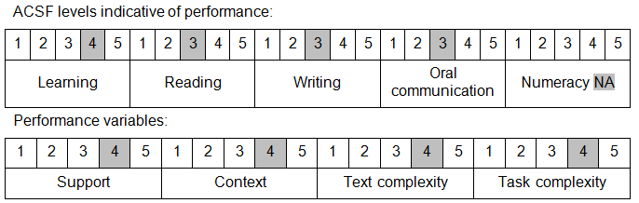

Further information on ACSF and the foundation skills underpinning this unit can be found in the Foundation Skills Guide on the GSA website.

Unit Mapping Information
This unit supersedes and is equivalent to PSPTIS603A Apply codes and standards to professional judgement.

Links
Companion Volume implementation guides are found in VETNet - https://vetnet.gov.au/Pages/TrainingDocs.aspx?q=bebbece7-ff48-4d2c-8876-405679019623
Companion Volume implementation guides are found in VETNet - https://vetnet.gov.au/Pages/TrainingDocs.aspx?q=bebbece7-ff48-4d2c-8876-405679019623
Companion Volume implementation guides are found in VETNet - https://vetnet.gov.au/Pages/TrainingDocs.aspx?q=bebbece7-ff48-4d2c-8876-405679019623
Companion Volume implementation guides are found in VETNet - https://vetnet.gov.au/Pages/TrainingDocs.aspx?q=bebbece7-ff48-4d2c-8876-405679019623

