PSPTIS093 Use complex legal terminology in interpreting (LOTE-English)
Release: 1

PSPTIS093 Use complex legal terminology in interpreting (LOTE-English)

Modification History
Release | Comments
1 | This unit was released in PSP Public Sector Training Package release 1.0 and meets the Standards for Training Packages.

Application
This unit describes the skills required to understand and use complex legal terminology in English and a LOTE sufficient to interpret between the two languages in complex dialogue or monologue settings in specialist legal and policing contexts.
This unit applies to those working as interpreters in a range of complex legal and policing contexts. The interpreter may be required to interact with members of the general public interacting with police, lawyers, the judiciary and court staff.
The skills and knowledge described in this unit must be applied within the legislative, regulatory and policy environment in which they are carried out. Organisational policies and procedures must be consulted and industry codes and standards for ethical translating and interpreting adhered to.
Those undertaking this unit would work independently using support resources as required, while performing complex tasks in a range of legal and policing contexts.
No licensing, legislative or certification requirements apply to unit at the time of publication.

Competency Field
Translating and interpreting

Elements and Performance Criteria
ELEMENTS | PERFORMANCE CRITERIA
Elements describe the essential outcomes | Performance criteria describe the performance needed to demonstrate achievement of the element. Where bold italicised text is used, further information is detailed in the range of conditions section.
1. Identify the context of legal terminology | 1.1 Identify key features of the legal and judicial system, including key people and structures.  1.2 Describe standard procedures specific to oral communication in formal legal and policing contexts.  1.3 Outline the role and responsibilities of interpreters and others in legal and policing contexts.  1.4 Identify social, cultural and professional conventions of English and LOTE appropriate to legal and judicial contexts.  1.5 Explain the consequences of oral rendition of fixed texts and use of incorrect legal terminology.
2. Extend understanding of legal terminology | 2.1 Recognise and explain complex legal terminology and key legal concepts and processes in English and LOTE.  2.2 Establish standard translations for fixed text encountered in policing and judicial contexts that correctly reflect underlying common law principles.  2.3 Research and increase knowledge of complex legal terminology in English and LOTE.  2.4 Spell and pronounce complex legal terminology correctly.
3. Use appropriate oral or signed communication in legal contexts | 3.1 Receive and understand oral or signed questions and answers using complex English and LOTE legal terminology.  3.2 Seek clarification of use and meaning of terms and associated processes.  3.3 Use a range of complex English and LOTE legal vocabulary and expressions in interpreting.  3.4 Use prosodic features, gestures and body language appropriate to the legal and policing context.

Foundation Skills
The foundation skills demands of this unit have been mapped for alignment with the Australian Core Skills Framework (ACSF). The following tables outline the performance levels indicated for successful attainment of the unit.

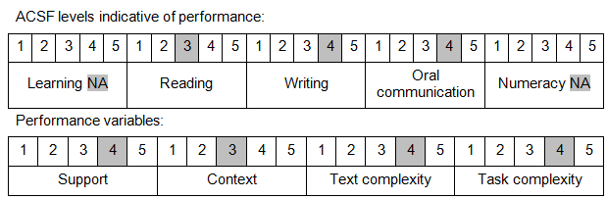

Further information on ACSF and the foundation skills underpinning this unit can be found in the Foundation Skills Guide on the GSA website.

Unit Mapping Information
No equivalent unit.

Links
Companion Volume implementation guides are found in VETNet - https://vetnet.gov.au/Pages/TrainingDocs.aspx?q=bebbece7-ff48-4d2c-8876-405679019623
Companion Volume implementation guides are found in VETNet - https://vetnet.gov.au/Pages/TrainingDocs.aspx?q=bebbece7-ff48-4d2c-8876-405679019623
Companion Volume implementation guides are found in VETNet - https://vetnet.gov.au/Pages/TrainingDocs.aspx?q=bebbece7-ff48-4d2c-8876-405679019623
Companion Volume implementation guides are found in VETNet - https://vetnet.gov.au/Pages/TrainingDocs.aspx?q=bebbece7-ff48-4d2c-8876-405679019623

