PSPTIS084 Sight translate (LOTE-English)
Release: 1

PSPTIS084 Sight translate (LOTE-English)

Modification History
Release | Comments
1 | This unit was released in PSP Public Sector Training Package release 1.0 and meets the Standards for Training Packages.  This unit supersedes and is equivalent to PSPTIS613A Sight translate (LOTE).  - Unit code updated  - Content and formatting updated to comply with the new standards  - All PC transitioned from passive to active voice  - PC1.5 removed

Application
This unit describes the skills required to produce a sight translation of a written source text in a different spoken or signed target language with a high degree of accuracy. Sight translation involves verbal or signed reproduction in a target language of a written source text in its entirety. It requires a high level of comprehension of written language and its structure, the ability to work between two languages in spoken or signed and written form, and the ability to reflect the register of the written source text in the target language.
This unit applies to interpreters who are required to sight translate texts as an adjunct to interpreting in any mode and complex setting, or to support consecutive or simultaneous interpreting.
The skills and knowledge described in this unit must be applied within the legislative, regulatory and policy environment in which they are carried out. Organisational policies and procedures must be consulted and industry codes and standards for ethical translating and interpreting adhered to.
Those undertaking this unit would work independently using a broad range of support resources as required, while performing routine tasks in a range of familiar contexts.
No licensing, legislative or certification requirements apply to unit at the time of publication.

Competency Field
Translating and interpreting

Elements and Performance Criteria
ELEMENTS | PERFORMANCE CRITERIA
Elements describe the essential outcomes | Performance criteria describe the performance needed to demonstrate achievement of the element. Where bold italicised text is used, further information is detailed in the range of conditions section.
1. Analyse text | 1.1 Confirm purpose for which sight translation is required and advise on appropriateness of sight translation.  1.2 Determine key features of text in context and confirm ability to read and comprehend the text.  1.3 Identify and discuss potential translation problems and confirm ability to sight translate and required timeframe.  1.4 Identify information in context and establish overall comprehension, referring to available resources and seeking further assistance where required.
2. Translate source text into target language | 2.1 Plan sight translation, marking up text where appropriate and identifying and solving translation problems.  2.2 Transfer semantic segments of source text to target language with attention to accuracy and coherence.  2.3 Scan text ahead while translating, avoiding rephrasing and ensuring delivery is consistent and appropriate for setting and mode of interpreting.
3. Evaluate sight translation | 3.1 Analyse performance to reflect task purpose and requirements.  3.2 Identify strengths and weaknesses of process to inform subsequent work.

Foundation Skills
The foundation skills demands of this unit have been mapped for alignment with the Australian Core Skills Framework (ACSF). The following tables outline the English language performance levels indicated for successful attainment of the unit.

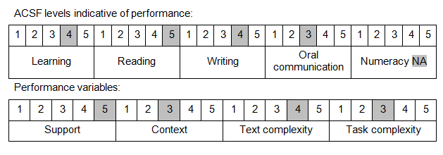

Further information on ACSF and the foundation skills underpinning this unit can be found in the Foundation Skills Guide on the GSA website.

Unit Mapping Information
This unit supersedes and is equivalent to PSPTIS613A Sight translate (LOTE).

Links
Companion Volume implementation guides are found in VETNet - https://vetnet.gov.au/Pages/TrainingDocs.aspx?q=bebbece7-ff48-4d2c-8876-405679019623
Companion Volume implementation guides are found in VETNet - https://vetnet.gov.au/Pages/TrainingDocs.aspx?q=bebbece7-ff48-4d2c-8876-405679019623
Companion Volume implementation guides are found in VETNet - https://vetnet.gov.au/Pages/TrainingDocs.aspx?q=bebbece7-ff48-4d2c-8876-405679019623
Companion Volume implementation guides are found in VETNet - https://vetnet.gov.au/Pages/TrainingDocs.aspx?q=bebbece7-ff48-4d2c-8876-405679019623

