PSPTIS069 Maintain and enhance professional practice
Release: 1

PSPTIS069 Maintain and enhance professional practice

Modification History
Release | Comments
1 | This unit was released in PSP Public Sector Training Package release 1.0 and meets the Standards for Training Packages.  This unit supersedes and is equivalent to PSPTIS504A Maintain and enhance professional practice.  - Element 1 PC re-ordered  - Element 3 PC revised  - Element 4 revised  - Unit code updated  - Content and formatting updated to comply with the new standards  - All PC transitioned from passive to active voice

Application
This unit describes the skills required to manage personal professional performance and to take responsibility for own professional development. It requires knowledge of the translation and interpreting industry and relevant professional development opportunities.
The unit applies to established translators and interpreters seeking to enhance their career and professional development.
The skills and knowledge described in this unit must be applied within the legislative, regulatory and policy environment in which they are carried out. Organisational policies and procedures must be consulted and codes and standards for ethical translating and interpreting adhered to.
Those undertaking this unit would work independently using support resources as required, while performing complex tasks in a range of contexts.
No licensing, legislative or certification requirements apply to unit at the time of publication.

Competency Field
Translating and interpreting

Elements and Performance Criteria
ELEMENTS | PERFORMANCE CRITERIA
Elements describe the essential outcomes | Performance criteria describe the performance needed to demonstrate achievement of the element. Where bold italicised text is used, further information is detailed in the range of conditions section.
1. Model high standards of performance | 1.1 Promote practitioner’s role with clients, colleagues and the public.  1.2 Determine individual responsibilities and accountabilities to reflect the requirements of contracts and work plans.  1.3 Model professional techniques and strategies for effective performance.
2. Determine personal development needs | 2.1 Assess personal skills and knowledge against industry competencies and other relevant benchmarks to determine development needs and priorities.  2.2 Use feedback from colleagues and clients to identify personal learning needs and areas for professional development.  2.3 Research future career options and career development pathways.  2.4 Seek advice on undertaking career development options.
3. Participate in professional development activities | 3.1 Identify and pursue formal and informal development activities to support continuous learning.  3.2 Maintain currency of professional practice through participation in professional association and networking events and activities.  3.3 Maintain industry relationships through relevant networks, organisations and individuals.
4. Evaluate and improve professional practice | 4.1 Research developments and trends impacting on professional practice and integrate these into work performance.  4.2 Identify and implement improvement strategies using feedback from colleagues and clients, and results of research.  4.3 Monitor own performance and apply innovative and responsive approaches for improving professional practice.

Foundation Skills
The foundation skills demands of this unit have been mapped for alignment with the Australian Core Skills Framework (ACSF). The following tables outline the performance levels indicated for successful attainment of the unit.

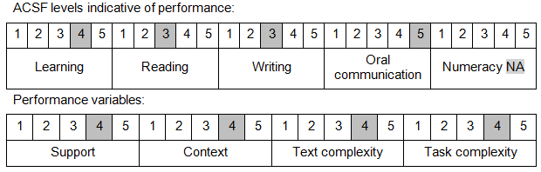

Further information on ACSF and the foundation skills underpinning this unit can be found in the Foundation Skills Guide on the GSA website.

Unit Mapping Information
This unit supersedes and is equivalent to PSPTIS504A Maintain and enhance professional practice.

Links
Companion Volume implementation guides are found in VETNet - https://vetnet.gov.au/Pages/TrainingDocs.aspx?q=bebbece7-ff48-4d2c-8876-405679019623
Companion Volume implementation guides are found in VETNet - https://vetnet.gov.au/Pages/TrainingDocs.aspx?q=bebbece7-ff48-4d2c-8876-405679019623
Companion Volume implementation guides are found in VETNet - https://vetnet.gov.au/Pages/TrainingDocs.aspx?q=bebbece7-ff48-4d2c-8876-405679019623
Companion Volume implementation guides are found in VETNet - https://vetnet.gov.au/Pages/TrainingDocs.aspx?q=bebbece7-ff48-4d2c-8876-405679019623

