PSPTIS065 Read and analyse special purpose LOTE texts to be translated
Release: 1

PSPTIS065 Read and analyse special purpose LOTE texts to be translated

Modification History
Release | Comments
1 | This unit was released in PSP Public Sector Training Package release 1.0 and meets the Standards for Training Packages.

Application
This unit describes the skills required to read and analyse a written message in a special purpose language other than English (LOTE) text for the purpose of later transfer to English. It requires identifying the key linguistic, cultural, societal and situational elements to be conveyed in the future language transfer process.
This unit applies to those working as translators of special purpose texts in any language.
Special purpose texts are texts for which the purpose is to convey information for a specific audience. The text is written using specific terminology and there may be significant equivalence problems between source and target texts. There may also be a need to undertake extensive research and translate complex language and concepts.
The skills and knowledge described in this unit must be applied within the legislative, regulatory and policy environment in which they are carried out. Organisational policies and procedures must be consulted and industry codes and standards for ethical translating and interpreting adhered to.
Those undertaking this unit would work independently using a broad range of support resources as required, while performing sophisticated tasks in a range of specialised contexts.
No licensing, legislative or certification requirements apply to unit at the time of publication.

Competency Field
Translating and interpreting

Elements and Performance Criteria
ELEMENTS | PERFORMANCE CRITERIA
Elements describe the essential outcomes | Performance criteria describe the performance needed to demonstrate achievement of the element. Where bold italicised text is used, further information is detailed in the range of conditions section.
1. Identify translating requirements and expectations of audience | 1.1 Identify source, context and purpose of text, determining specific requirements and regional or specialist aspects.  1.2 Identify audience for translated text and confirm that translation requirements and expectations match those of client.  1.3 Identify social and cultural issues and plan solutions relevant to translation task.
2. Analyse language of source text | 2.1 Identify source language, including register and style.  2.2 Identify complex areas of content and language requiring additional research.  2.3 Confirm and review resources to aid in understanding specialist or technical language.  2.4 Build, use and maintain assignment-specific glossary.  2.5 Recognise idiomatic and metaphorical expressions and foreign loan words in source text.  2.6 Analyse language and writing conventions, determining use of terminology and language.
3. Analyse grammar and cohesion of source text | 3.1 Analyse function of LOTE punctuation and determine semantic and syntactic structure.  3.2 Apply subject and context knowledge and experiences in related texts to determine key elements and potential translation problems.  3.3 Paraphrase text to check plausibility of comprehension.  3.4 Restructure text as necessary to clarify meaning.
4. Resolve difficulties | 4.1 Identify deficient source text and discuss with appropriate persons.  4.2 Suggest solutions and reformulate text as agreed for effective translation.  4.3 Use a range of techniques and resources to address and resolve difficulties identified.

Foundation Skills
The foundation skills demands of this unit have been mapped for alignment with the Australian Core Skills Framework (ACSF). The following tables outline the English language performance levels indicated for successful attainment of the unit.

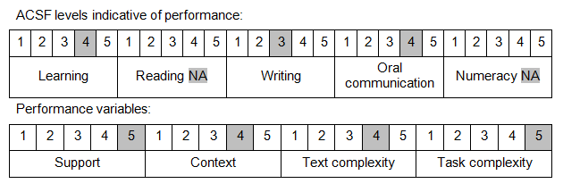

Further information on ACSF and the foundation skills underpinning this unit can be found in the Foundation Skills Guide on the GSA website.

Unit Mapping Information
No equivalent unit.

Links
Companion Volume implementation guides are found in VETNet - https://vetnet.gov.au/Pages/TrainingDocs.aspx?q=bebbece7-ff48-4d2c-8876-405679019623
Companion Volume implementation guides are found in VETNet - https://vetnet.gov.au/Pages/TrainingDocs.aspx?q=bebbece7-ff48-4d2c-8876-405679019623
Companion Volume implementation guides are found in VETNet - https://vetnet.gov.au/Pages/TrainingDocs.aspx?q=bebbece7-ff48-4d2c-8876-405679019623
Companion Volume implementation guides are found in VETNet - https://vetnet.gov.au/Pages/TrainingDocs.aspx?q=bebbece7-ff48-4d2c-8876-405679019623

