PSPTIS060 Analyse text types for translation of special purpose texts (LOTE-English)
Release: 1

PSPTIS060 Analyse text types for translation of special purpose texts (LOTE-English)

Modification History
Release | Comments
1 | This unit was released in PSP Public Sector Training Package release 1.0 and meets the Standards for Training Packages.

Application
This unit describes the skills required to analyse a special purpose source text in one language, identify the text type, and apply the analysis in translation to another language.
This unit applies to those working as translators of special purpose texts, where there are significant equivalence problems between source and target texts. There may also be a need to undertake extensive research and translate complex language and concepts. The purpose of special purpose texts is to convey information for a specific audience.
The skills and knowledge described in this unit must be applied within the legislative, regulatory and policy environment in which they are carried out. Organisational policies and procedures must be consulted and industry codes and standards for ethical translating and interpreting adhered to.
Those undertaking this unit would work independently using a broad range of support resources as required, while performing sophisticated tasks in a range of specialised contexts.
No licensing, legislative or certification requirements apply to unit at the time of publication.

Competency Field
Translating and interpreting

Elements and Performance Criteria
ELEMENTS | PERFORMANCE CRITERIA
Elements describe the essential outcomes | Performance criteria describe the performance needed to demonstrate achievement of the element. Where bold italicised text is used, further information is detailed in the range of conditions section.
1. Analyse source text | 1.1 Assess structure and identify text type.  1.2 Identify devices and sequencing that achieve document objectives in the source text.  1.3 Review devices and sequencing in context of structure and content and confirm logic and correctness.  1.4 Identify culturally specific meaning.
2. Identify requirements of translation | 2.1 Determine audience and purpose for translation.  2.2 Establish method and means of communication.  2.3 Determine requirements of target language text type documents.  2.4 Determine appropriate format and structure in target language.
3. Consider target text requirements | 3.1 Consider translation options according to target text type document requirements and genre.  3.2 Identify appropriate language, considering suitability for audience, purpose, format and communication style.  3.3 Ensure content addresses cultural and social differences and idiolects.  3.4 Identify any problems with source document and seek advice from appropriate persons.
4. Apply analysis to translation | 4.1 Apply requirements of the subject and cultural context to translation.  4.2 Apply recognised target language conventions, standards and formats to translation.  4.3 Produce written or word processed documents, applying basic design elements to text.  4.4 Ensure text type document objectives are achieved and requirements are met in target text.

Foundation Skills
The foundation skills demands of this unit have been mapped for alignment with the Australian Core Skills Framework (ACSF). The following tables outline the performance levels indicated for successful attainment of the unit.

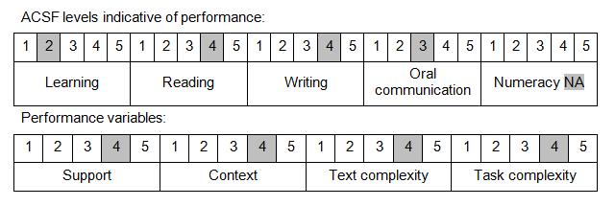

Further information on ACSF and the foundation skills underpinning this unit can be found in the Foundation Skills Guide on the GSA website.

Range of Conditions
Special purpose text types must include at least five of: | - correspondence  - essays  - informative and expository texts  - instructive texts  - media statements and articles  - narrative and descriptive texts  - persuasive and marketing texts  - reports  - speeches

Unit Mapping Information
No equivalent unit.

Links
Companion Volume implementation guides are found in VETNet - https://vetnet.gov.au/Pages/TrainingDocs.aspx?q=bebbece7-ff48-4d2c-8876-405679019623
Companion Volume implementation guides are found in VETNet - https://vetnet.gov.au/Pages/TrainingDocs.aspx?q=bebbece7-ff48-4d2c-8876-405679019623
Companion Volume implementation guides are found in VETNet - https://vetnet.gov.au/Pages/TrainingDocs.aspx?q=bebbece7-ff48-4d2c-8876-405679019623
Companion Volume implementation guides are found in VETNet - https://vetnet.gov.au/Pages/TrainingDocs.aspx?q=bebbece7-ff48-4d2c-8876-405679019623

