PSPTIS043 Use routine subject matter terminology in interpreting (LOTE-English)
Release: 1

PSPTIS043 Use routine subject matter terminology in interpreting (LOTE-English)

Modification History
Release | Comments
1 | This unit was released in PSP Public Sector Training Package release 1.0 and meets the Standards for Training Packages.

Application
This unit describes the skills required to understand and use terminology from specific subject areas in English and a LOTE sufficient to interpret between the two languages in general dialogue or monologue settings in those subject areas.
This unit applies to those working as interpreters in a range of contexts.
The skills and knowledge described in this unit must be applied within the legislative, regulatory and policy environment in which they are carried out. Organisational policies and procedures must be consulted and industry codes and standards for ethical translating and interpreting adhered to.
Those undertaking this unit would work independently using support resources as required, while performing specific tasks in a range of contexts.
No licensing, legislative or certification requirements apply to unit at the time of publication.

Competency Field
Translating and interpreting

Elements and Performance Criteria
ELEMENTS | PERFORMANCE CRITERIA
Elements describe the essential outcomes | Performance criteria describe the performance needed to demonstrate achievement of the element. Where bold italicised text is used, further information is detailed in the range of conditions section.
1. Identify the context of the terminology | 1.1 Identify key features of the subject area, including key people and institutions.  1.2 Identify standard procedures specific to communication in the subject area context.  1.3 Discuss the role and responsibility of interpreters and others in the subject area contexts.  1.4 Identify social, cultural and professional conventions of English and LOTE appropriate to the subject area contexts.
2. Develop understanding of the subject area | 2.1 Research and develop knowledge of the subject area terminology in English and LOTE.  2.2 Pronounce general terminology from the subject area correctly.
3. Use appropriate oral or signed communication in interpreting | 3.1 Receive and understand oral or signed communication using English and LOTE subject area terminology.  3.2 Seek advice from appropriate persons as necessary to clarify correct use and meaning of terms and associated processes.  3.3 Use general English and LOTE subject area terminology correctly in interpreting.  3.4 Use prosodic features, gestures and body language appropriate to the subject area context.

Foundation Skills
The foundation skills demands of this unit have been mapped for alignment with the Australian Core Skills Framework (ACSF). The following tables outline the performance levels indicated for successful attainment of the unit.

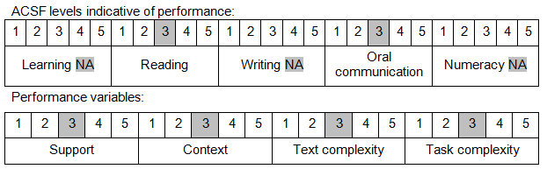

Further information on ACSF and the foundation skills underpinning this unit can be found in the Foundation Skills Guide on the GSA website.

Range of Conditions
Basic subject areas must include at least five of: | - government and elections  - education  - environment  - immigration and settlement  - money matters  - social welfare  - tourism and events

Unit Mapping Information
No equivalent unit.

Links
Companion Volume implementation guides are found in VETNet - https://vetnet.gov.au/Pages/TrainingDocs.aspx?q=bebbece7-ff48-4d2c-8876-405679019623
Companion Volume implementation guides are found in VETNet - https://vetnet.gov.au/Pages/TrainingDocs.aspx?q=bebbece7-ff48-4d2c-8876-405679019623
Companion Volume implementation guides are found in VETNet - https://vetnet.gov.au/Pages/TrainingDocs.aspx?q=bebbece7-ff48-4d2c-8876-405679019623
Companion Volume implementation guides are found in VETNet - https://vetnet.gov.au/Pages/TrainingDocs.aspx?q=bebbece7-ff48-4d2c-8876-405679019623

