PSPTIS004 Conduct career planning
Release: 1

PSPTIS004 Conduct career planning

Modification History
Release | Comments
1 | This unit was released in PSP Public Sector Training Package release 1.0 and meets the Standards for Training Packages.

Application
This unit describes the skills required to identify the scope and nature of work within the translating and interpreting sector. It describes the skills needed to identify work options, determine own skills and knowledge, establish professional connections or networks and develop a career plan.
The unit applies to emerging translators and interpreters seeking to plan their career.
The skills and knowledge described in this unit must be applied within the legislative, regulatory and policy environment in which they are carried out. Organisational policies and procedures must be consulted and industry codes and standards for ethical translating and interpreting adhered to.
Those undertaking this unit would work independently using support resources as required, while performing specific tasks in a range of contexts.
No licensing, legislative or certification requirements apply to this unit at the time of publication.

Competency Field
Translating and interpreting

Elements and Performance Criteria
ELEMENTS | PERFORMANCE CRITERIA
Elements describe the essential outcomes | Performance criteria describe the performance needed to demonstrate achievement of the element. Where bold italicised text is used, further information is detailed in the range of conditions section.
1. Identify scope and nature of work context | 1.1 Identify main participants in sector.  1.2 Determine nature of work, current and future trends and potential impacts.  1.3 Identify avenues for exploring work opportunities.  1.4 Clarify skill and knowledge requirements for specific fields.  1.5 Identify relevant ethical codes, quality standards and employment conditions.
2. Conduct self-assessment | 2.1 List own knowledge, experience and current and potential abilities in relation to specific fields.  2.2 Explore personal values and work preferences.  2.3 Prepare a profile that identifies personal attributes relevant to chosen career.
3. Investigate career options | 3.1 Identify own career options and select preferred options.  3.2 Determine gaps in own skills and knowledge.  3.3 Investigate formal and informal training opportunities and language or skill development for selected options.
4. Develop an individual career plan | 4.1 Identify strategies to develop required skills and knowledge.  4.2 Develop a career plan to implement strategies.  4.3 Review career plan with established practitioners.

Foundation Skills
The foundation skills demands of this unit have been mapped for alignment with the Australian Core Skills Framework (ACSF). The following tables outline the performance levels indicated for successful attainment of the unit.

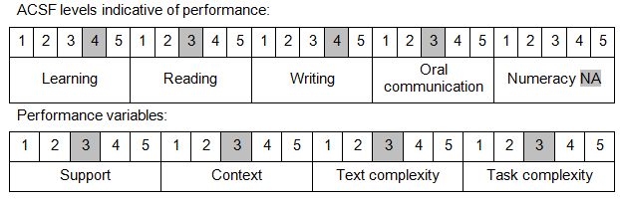

Further information on ACSF and the foundation skills underpinning this unit can be found in the Foundation Skills Guide on the GSA website.

Unit Mapping Information
No equivalent unit.

Links
Companion Volume implementation guides are found in VETNet - https://vetnet.gov.au/Pages/TrainingDocs.aspx?q=bebbece7-ff48-4d2c-8876-405679019623
Companion Volume implementation guides are found in VETNet - https://vetnet.gov.au/Pages/TrainingDocs.aspx?q=bebbece7-ff48-4d2c-8876-405679019623
Companion Volume implementation guides are found in VETNet - https://vetnet.gov.au/Pages/TrainingDocs.aspx?q=bebbece7-ff48-4d2c-8876-405679019623
Companion Volume implementation guides are found in VETNet - https://vetnet.gov.au/Pages/TrainingDocs.aspx?q=bebbece7-ff48-4d2c-8876-405679019623

