PSPTIS002 Build glossaries for translating and interpreting assignments
Release: 1

PSPTIS002 Build glossaries for translating and interpreting assignments

Modification History
Release | Comments
1 | This unit was released in PSP Public Sector Training Package release 1.0 and meets the Standards for Training Packages.

Application
This unit describes the skills required to develop glossaries for translating and interpreting assignments. It includes the ability to identify and source suitable reference material, and to make efficient use of tools and equipment.
This unit applies to those working as translators and interpreters who are responsible for minimising risks associated with inadequate preparation, or collaborating with colleagues in translating and interpreting tasks.
The skills and knowledge described in this unit must be applied within the legislative, regulatory and policy environment in which they are carried out. Organisational policies and procedures should be consulted and industry codes and standards for ethical translating and interpreting adhered to.
Those undertaking this unit would work independently using support resources as required while performing specific tasks in a range of contexts.
No licensing, legislative or certification requirements apply to unit at the time of publication.

Competency Field
Translating and interpreting

Elements and Performance Criteria
ELEMENTS | PERFORMANCE CRITERIA
Elements describe the essential outcomes | Performance criteria describe the performance needed to demonstrate achievement of the element. Where bold italicised text is used, further information is detailed in the range of conditions section.
1. Analyse assignment information | 1.1 Obtain and analyse assignment documentation and related background material.  1.2 Consider assignment requirements and need for glossary sharing to decide approach and format.  1.3 Select and obtain tools and equipment and identify up-to-date, relevant and comprehensive resources.
2. Establish familiarity with topic and context | 2.1 Access and make critical use of sources of information and reference material.  2.2 Critically analyse terminology in context and record selections in assignment-specific glossary template.  2.3 Identify areas requiring further subject knowledge and seek additional information from client, specialist advisors, or colleagues.
3. Review and evaluate glossary | 3.1 Review preparation to confirm it addresses assignment requirements and update glossary as necessary.  3.2 Consider and implement adjustments to improve process and outcomes of future preparation.

Foundation Skills
The foundation skills demands of this unit have been mapped for alignment with the Australian Core Skills Framework (ACSF). The following tables outline the performance levels indicated for successful attainment of the unit.

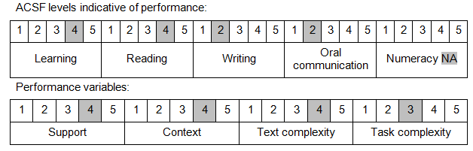

Further information on ACSF and the foundation skills underpinning this unit can be found in the Foundation Skills Guide on the GSA website.

Unit Mapping Information
No equivalent unit.

Links
Companion Volume implementation guides are found in VETNet - https://vetnet.gov.au/Pages/TrainingDocs.aspx?q=bebbece7-ff48-4d2c-8876-405679019623
Companion Volume implementation guides are found in VETNet - https://vetnet.gov.au/Pages/TrainingDocs.aspx?q=bebbece7-ff48-4d2c-8876-405679019623
Companion Volume implementation guides are found in VETNet - https://vetnet.gov.au/Pages/TrainingDocs.aspx?q=bebbece7-ff48-4d2c-8876-405679019623
Companion Volume implementation guides are found in VETNet - https://vetnet.gov.au/Pages/TrainingDocs.aspx?q=bebbece7-ff48-4d2c-8876-405679019623

