PSPTIS001 Apply codes and standards to ethical practice
Release: 1

PSPTIS001 Apply codes and standards to ethical practice

Modification History
Release | Comments
1 | This unit was released in PSP Public Sector Training Package release 1.0 and meets the Standards for Training Packages.  This unit supersedes and is equivalent to PSPTIS503A Apply codes and standards to ethical practice.  - Unit code updated  - Content and formatting updated to comply with the new standards  - All PC transitioned from passive to active voice  - PC 2.3 split into two PC  - 2.1 moved to Element 3

Application
This unit describes the skills required to ensure that translators and interpreters apply current and relevant standards of professional and ethical behaviour in general settings. The unit requires knowledge of the industry’s professional codes of ethics and their application to practice. It requires the ability to consider a range of ethical issues and to reflect on and continuously develop professional practice.
This unit applies to those working as translators and interpreters in a range of general settings.
The skills and knowledge described in this unit must be applied within the legislative, regulatory and policy environment in which they are carried out. Organisational policies and procedures should be consulted and industry codes and standards for ethical translating and interpreting adhered to.
Those undertaking this unit would work independently using support resources as required, while performing specific tasks in a range of familiar contexts.
No licensing, legislative or certification requirements apply to unit at the time of publication.

Competency Field
Translating and interpreting

Elements and Performance Criteria
ELEMENTS | PERFORMANCE CRITERIA
Elements describe the essential outcomes | Performance criteria describe the performance needed to demonstrate achievement of the element. Where bold italicised text is used, further information is detailed in the range of conditions section.
1. Develop knowledge of ethical and professional issues | 1.1 Use reliable sources of information to ensure that knowledge of ethical issues and professional practice is current, comprehensive and relevant.  1.2 Maintain professional relationships and networks to facilitate awareness of current issues.  1.3 Analyse applicable codes of ethics and conduct and their relationship to work practices.
2. Apply ethical standards to professional practices | 2.1 Identify and examine factors that impact on professional and ethical decision making.  2.2 Apply codes and standards of ethical conduct to assignments.  2.3 Develop and promote strategies for dealing with possible dilemmas.  2.4 Promote ethical standards and practice with clients, colleagues and others.
3. Evaluate professional practices and knowledge related to ethical practice | 3.1 Reflect on and evaluate ethical practices in work assignments.  3.2 Monitor and review practice in relation to standards of ethics and conduct.  3.3 Seek advice and feedback on performance to improve ethical practice.  3.4 Participate in professional development activities and networks to address identified needs in current ethical practice.

Foundation Skills
The foundation skills demands of this unit have been mapped for alignment with the Australian Core Skills Framework (ACSF). The following tables outline the performance levels indicated for successful attainment of the unit.

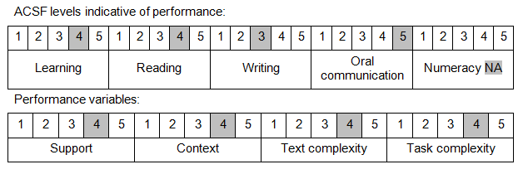

Further information on ACSF and the foundation skills underpinning this unit can be found in the Foundation Skills Guide on the GSA website.

Unit Mapping Information
This unit supersedes and is equivalent to PSPTIS503A Apply codes and standards to ethical practice.

Links
Companion Volume implementation guides are found in VETNet - https://vetnet.gov.au/Pages/TrainingDocs.aspx?q=bebbece7-ff48-4d2c-8876-405679019623
Companion Volume implementation guides are found in VETNet - https://vetnet.gov.au/Pages/TrainingDocs.aspx?q=bebbece7-ff48-4d2c-8876-405679019623
Companion Volume implementation guides are found in VETNet - https://vetnet.gov.au/Pages/TrainingDocs.aspx?q=bebbece7-ff48-4d2c-8876-405679019623
Companion Volume implementation guides are found in VETNet - https://vetnet.gov.au/Pages/TrainingDocs.aspx?q=bebbece7-ff48-4d2c-8876-405679019623

