PSPSEC017 Manage security awareness
Release: 1

PSPSEC017 Manage security awareness

Modification History
Release | Comments
1 | This unit was released in PSP Public Sector Training Package release 1.0 and meets the Standards for Training Packages.  This unit supersedes and is equivalent to PSPSEC602A Manage security awareness.  - Unit code updated  - Content and formatting updated to comply with new standards  - All PC transitioned from passive to active voice

Application
This unit describes the skills required to promote and disseminate the organisation’s approach to security management to internal and external clients and the broader community.
This unit applies to those whose roles include disseminating strategy and championing security awareness both inside and outside the organisation.
The skills and knowledge described in this unit must be applied within the legislative, regulatory and policy environment in which they are carried out. Organisational policies and procedures must be consulted and adhered to, particularly those related to managing security awareness.
Those undertaking this unit would work autonomously, frequently accessing and evaluating support from a broad range of sources. They would perform highly sophisticated tasks in a broad range of contexts with frequent specialisation in one or more contexts.
No licensing, legislative or certification requirements apply to unit at the time of publication.

Competency Field
Security

Elements and Performance Criteria
ELEMENTS | PERFORMANCE CRITERIA
Elements describe the essential outcomes | Performance criteria describe the performance needed to demonstrate achievement of the element. Where bold italicised text is used, further information is detailed in the range of conditions section.
1. Disseminate security policy | 1.1 Raise the profile of security management to indicate its fundamental importance within the organisation.  1.2 Articulate security standards for the organisation in a manner suited to the level and experience of staff.  1.3 Explain ways in which the security policy and plan contribute to the achievement of organisational corporate goals.  1.4 Communicate roles and responsibilities of key people in the organisation regarding implementation of security measures.  1.5 Present and disseminate information to meet the needs of diverse audiences.
2. Champion security awareness | 2.1 Lead and motivate others in promoting the role of security processes as integral to effective management practices.  2.2 Use methods to champion security awareness based on an in-depth understanding of the organisation’s culture and structure and the nature of both internal and external clients.  2.3 Establish a positive tone within the organisation regarding security, by engendering trust and confidence in security measures.  2.4 Establish guidelines for the creation of formal and informal networks and to nurture cooperative and ethical client relationships.
3. Market security management inside and outside the organisation | 3.1 Identify and assess potential activities to promote security and its importance to the overall objectives of the organisation in relation to the current security policy and plan.  3.2 Coordinate implementation of activities with management and key stakeholders.  3.3 Encourage shared ownership of security processes through ongoing consultation and information sharing.  3.4 Organise promotional activities to raise stakeholder awareness of both the ethical and financial aspects of security and to endorse the concept and practice of security management.  3.5 Monitor trends in order to ensure currency of the organisation’s security measures.

Foundation Skills
The foundation skills demands of this unit have been mapped for alignment with the Australian Core Skills Framework (ACSF). The following tables outline the performance levels indicated for successful attainment of the unit.

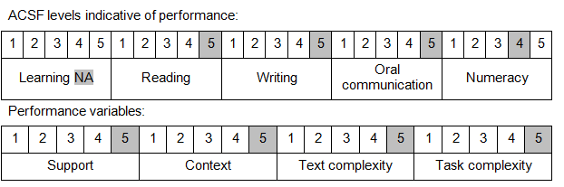

Further information on ACSF and the foundation skills underpinning this unit can be found in the Foundation Skills Guide on the GSA website.

Unit Mapping Information
This unit supersedes and is equivalent to PSPSEC602A Manage security awareness.

Links
Companion Volume implementation guides are found in VETNet - https://vetnet.gov.au/Pages/TrainingDocs.aspx?q=bebbece7-ff48-4d2c-8876-405679019623
Companion Volume implementation guides are found in VETNet - https://vetnet.gov.au/Pages/TrainingDocs.aspx?q=bebbece7-ff48-4d2c-8876-405679019623
Companion Volume implementation guides are found in VETNet - https://vetnet.gov.au/Pages/TrainingDocs.aspx?q=bebbece7-ff48-4d2c-8876-405679019623
Companion Volume implementation guides are found in VETNet - https://vetnet.gov.au/Pages/TrainingDocs.aspx?q=bebbece7-ff48-4d2c-8876-405679019623

