PSPSEC016 Define information systems framework
Release: 1

PSPSEC016 Define information systems framework

Modification History
Release | Comments
1 | This unit was released in PSP Public Sector Training Package release 1.0 and meets the Standards for Training Packages.  This unit supersedes and is equivalent to PSPSEC601A Define information systems framework.  - Unit code updated  - Content and formatting updated to comply with new standards  - All PC transitioned from passive to active voice

Application
This unit describes the skills required to identify and establish the information system security framework for an organisation or a business unit at functional level. It includes determining the organisational context, determining principal areas of risk, determining system requirements and establishing the security framework.
This unit applies to those with organisation-wide responsibility for defining systems and procedures which impact on organisational security.
The skills and knowledge described in this unit must be applied within the legislative, regulatory and policy environment in which they are carried out. Organisational policies and procedures must be consulted and adhered to, particularly those related to defining information systems for security.
Those undertaking this unit would work autonomously while frequently accessing and evaluating support from a broad range of sources. They would perform sophisticated tasks in a broad range of contexts.
No licensing, legislative or certification requirements apply to unit at the time of publication.

Competency Field
Security

Elements and Performance Criteria
ELEMENTS | PERFORMANCE CRITERIA
Elements describe the essential outcomes | Performance criteria describe the performance needed to demonstrate achievement of the element. Where bold italicised text is used, further information is detailed in the range of conditions section.
1. Establish the organisational context | 1.1 Identify and document legislative and regulatory requirements for the organisation.  1.2 Analyse legislation for any information management security implications and document outcomes.  1.3 Review organisational purpose and function for compliance requirements.  1.4 Analyse broad social context in which the organisation operates to determine community expectations.
2. Determine the principal areas of risk requiring information strategy | 2.1 Review and update existing risk analyses.  2.2 Review and document regulatory requirements and legal liabilities for their impact on the information systems framework.  2.3 Determine and document risks and liabilities to be managed by information systems, informing the development of the framework.
3. Determine the information system requirements for each business function | 3.1 Analyse risks, liabilities and regulatory requirements.  3.2 Document and communicate identified requirements as evidence to be captured as records.  3.3 Formulate information system specifications from the evidence requirements.  3.4 Determine information security requirements.  3.5 Determine specifications for information systems security measures.
4. Establish information systems framework for organisation | 4.1 Develop and communicate an overview of responsibilities for information management within the organisation.  4.2 Define responsibilities and authorities in relation to regulatory requirements.  4.3 Define information management responsibilities and rights for each business function.  4.4 Integrate identified risks and liabilities managed by information systems.  4.5 Define, assign and document levels of accountability and responsibility within the framework.  4.6 Formulate and document security procedures for information systems.
5. Obtain approval for framework | 5.1 Communicate completed and documented framework for review and endorsement.  5.2 Establish review process and assign appropriate persons with maintaining the currency of the organisation’s information systems framework.

Foundation Skills
The foundation skills demands of this unit have been mapped for alignment with the Australian Core Skills Framework (ACSF). The following tables outline the performance levels indicated for successful attainment of the unit.

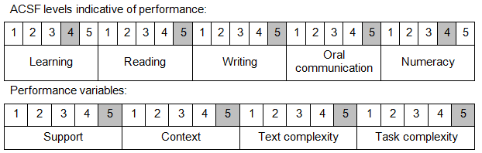

Further information on ACSF and the foundation skills underpinning this unit can be found in the Foundation Skills Guide on the GSA website.

Unit Mapping Information
This unit supersedes and is equivalent to PSPSEC601A Define information systems framework.

Links
Companion Volume implementation guides are found in VETNet - https://vetnet.gov.au/Pages/TrainingDocs.aspx?q=bebbece7-ff48-4d2c-8876-405679019623
Companion Volume implementation guides are found in VETNet - https://vetnet.gov.au/Pages/TrainingDocs.aspx?q=bebbece7-ff48-4d2c-8876-405679019623
Companion Volume implementation guides are found in VETNet - https://vetnet.gov.au/Pages/TrainingDocs.aspx?q=bebbece7-ff48-4d2c-8876-405679019623
Companion Volume implementation guides are found in VETNet - https://vetnet.gov.au/Pages/TrainingDocs.aspx?q=bebbece7-ff48-4d2c-8876-405679019623

