PSPSEC014 Coordinate protective security
Release: 1

PSPSEC014 Coordinate protective security

Modification History
Release | Comments
1 | This unit was released in PSP Public Sector Training Package release 1.0 and meets the Standards for Training Packages.  This unit supersedes and is equivalent to PSPSEC504A Coordinate protective security.  - Unit code updated  - Content and formatting updated to comply with new standards  - All PC transitioned from passive to active voice

Application
This unit describes the skills required to perform an organisation’s ongoing protective security function through implementing security procedures and systems. It includes providing advice and support to others, monitoring and coordinating security, and liaising with specialist security services.
This unit applies to those with day-to-day responsibility for an organisation’s protective security function.
The skills and knowledge described in this unit must be applied within the legislative, regulatory and policy environment in which they are carried out. Organisational policies and procedures must be consulted and adhered to, particularly those related to security and privacy legislation and security standards when coordinating protective security.
Those undertaking this unit would work autonomously, occasionally accessing support from a range of sources, while performing complex tasks in a range of contexts.
No licensing, legislative or certification requirements apply to unit at the time of publication.

Competency Field
Security

Elements and Performance Criteria
ELEMENTS | PERFORMANCE CRITERIA
Elements describe the essential outcomes | Performance criteria describe the performance needed to demonstrate achievement of the element. Where bold italicised text is used, further information is detailed in the range of conditions section.
1. Provide security advice and support | 1.1 Assist management to analyse the security environment and plan to counter potential threats.  1.2 Advise management on physical and procedural security measures.  1.3 Assist in development of the organisation’s security policy and procedures in consultation with management and staff.  1.4 Promote self as the first point of contact for security concerns and queries within the organisation.  1.5 Advise on security matters.
2. Coordinate and monitor security | 2.1 Develop and implement protective security arrangements in conjunction with senior management to create and maintain a secure environment for official information and resources.  2.2 Coordinate devolved security measures to ensure organisational standards are maintained consistently and cost-effectively.  2.3 Monitor organisational security procedures and systems and audit as required by the organisation’s security policy and plan.  2.4 Monitor the awareness of employees and contractors in terms of their security responsibilities and obligations, take action or make recommendation to address any gaps.  2.5 Review incident reports and assess implications for security risk, procedures and awareness training.
3. Access security specialists | 3.1 Coordinate contact between the organisation and external security authorities/organisations.  3.2 Seek advice, technical assistance, learning and development from specialist security organisations to ensure compliance with jurisdictional and organisational security policies, procedures and standards.  3.3 Report or refer incidents and other security issues to government security authorities.

Foundation Skills
The foundation skills demands of this unit have been mapped for alignment with the Australian Core Skills Framework (ACSF). The following tables outline the performance levels indicated for successful attainment of the unit.

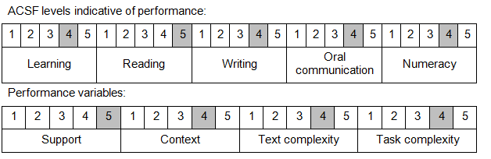

Further information on ACSF and the foundation skills underpinning this unit can be found in the Foundation Skills Guide on the GSA website.

Unit Mapping Information
This unit supersedes and is equivalent to PSPSEC504A Coordinate protective security.

Links
Companion Volume implementation guides are found in VETNet - https://vetnet.gov.au/Pages/TrainingDocs.aspx?q=bebbece7-ff48-4d2c-8876-405679019623
Companion Volume implementation guides are found in VETNet - https://vetnet.gov.au/Pages/TrainingDocs.aspx?q=bebbece7-ff48-4d2c-8876-405679019623
Companion Volume implementation guides are found in VETNet - https://vetnet.gov.au/Pages/TrainingDocs.aspx?q=bebbece7-ff48-4d2c-8876-405679019623
Companion Volume implementation guides are found in VETNet - https://vetnet.gov.au/Pages/TrainingDocs.aspx?q=bebbece7-ff48-4d2c-8876-405679019623

