PSPSEC012 Develop security risk management plans
Release: 1

PSPSEC012 Develop security risk management plans

Modification History
Release | Comments
1 | This unit was released in PSP Public Sector Training Package release 1.0 and meets the Standards for Training Packages.  This unit supersedes and is equivalent to PSPSEC502A Develop security risk management plans.  - Unit code updated  - Content and formatting updated to comply with new standards  - All PC transitioned from passive to active voice  - PC 2.1 and 2.2 merged

Application
This unit describes the skills required to treat security risks through the development of a security risk management plan. It includes identifying security countermeasures and developing a plan with schedule for implementing, monitoring and evaluating security strategies.
This unit applies to those working in a security role with some responsibility for addressing organisational risk.
The skills and knowledge described in this unit must be applied within the legislative, regulatory and policy environment in which they are carried out. Organisational policies and procedures must be consulted and adhered to, particularly those related to developing risk management plans.
Those undertaking this unit would work autonomously occasionally accessing and evaluating support from a broad range of sources. They would perform complex tasks in a range of familiar and unfamiliar contexts.
No licensing, legislative or certification requirements apply to unit at the time of publication.

Competency Field
Security

Elements and Performance Criteria
ELEMENTS | PERFORMANCE CRITERIA
Elements describe the essential outcomes | Performance criteria describe the performance needed to demonstrate achievement of the element. Where bold italicised text is used, further information is detailed in the range of conditions section.
1. Identify counter-measures | 1.1 Review documented risks and threats and validate management decisions on acceptable and unacceptable risks.  1.2 Determine treatment options and countermeasures to reduce the likelihood of occurrence or consequences of the risk.  1.3 Propose treatments which include continuity plans where appropriate.  1.4 Propose treatments which match the level and type of risk and importance of the function or resource.  1.5 Conduct a cost-benefit analysis to determine countermeasures.  1.6 Consult stakeholders on the cost-benefit analysis and determine and submit countermeasures for prioritising.
2. Develop security plan | 2.1 Prepare a security plan containing explanatory information on the importance of security and the organisation’s security objectives in achieving corporate and business objectives.  2.2 Summarise the threat assessments undertaken, current exposure and current protective security arrangements in the plan.  2.3 Outline security strategies for implementing, monitoring and evaluating countermeasures.  2.4 Include timeframes and security budget for implementing countermeasures including assigned responsibilities and methodologies to be used.  2.5 Submit security plan for approval and communicate to stakeholders.

Foundation Skills
The foundation skills demands of this unit have been mapped for alignment with the Australian Core Skills Framework (ACSF). The following tables outline the performance levels indicated for successful attainment of the unit.

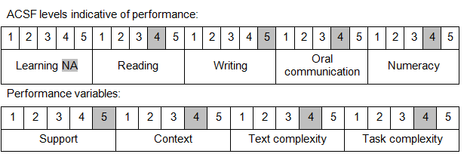

Further information on ACSF and the foundation skills underpinning this unit can be found in the Foundation Skills Guide on the GSA website.

Unit Mapping Information
This unit supersedes and is equivalent to PSPSEC502A Develop security risk management plans.

Links
Companion Volume implementation guides are found in VETNet - https://vetnet.gov.au/Pages/TrainingDocs.aspx?q=bebbece7-ff48-4d2c-8876-405679019623
Companion Volume implementation guides are found in VETNet - https://vetnet.gov.au/Pages/TrainingDocs.aspx?q=bebbece7-ff48-4d2c-8876-405679019623
Companion Volume implementation guides are found in VETNet - https://vetnet.gov.au/Pages/TrainingDocs.aspx?q=bebbece7-ff48-4d2c-8876-405679019623
Companion Volume implementation guides are found in VETNet - https://vetnet.gov.au/Pages/TrainingDocs.aspx?q=bebbece7-ff48-4d2c-8876-405679019623

