PSPSEC008 Conduct personnel security assessments
Release: 1

PSPSEC008 Conduct personnel security assessments

Modification History
Release | Comments
1 | This unit was released in PSP Public Sector Training Package release 1.0 and meets the Standards for Training Packages.  This unit supersedes and is equivalent to PSPSEC404A Conduct personnel security assessments.  - Unit code updated  - Content and formatting updated to comply with new standards  - All PC transitioned from passive to active voice  - PC 2.1 and 2.2, PC 2.3 and 2.4 merged  - PC 3.3 removed

Application
This unit describes the skills required to collect, analyse and evaluate personal information, make recommendations on security assessment outcomes and record and report on personnel security assessments.
This unit applies to those working in the security sector required to make assessments.
The skills and knowledge described in this unit must be applied within the legislative, regulatory and policy environment in which they are carried out. Organisational policies and procedures must be consulted and adhered to.
Those undertaking this unit would generally work independently and as part of a team using support resources as required. They would perform complex tasks in a range of familiar and unfamiliar contexts.
No licensing, legislative or certification requirements apply to unit at the time of publication.

Competency Field
Security

Elements and Performance Criteria
ELEMENTS | PERFORMANCE CRITERIA
Elements describe the essential outcomes | Performance criteria describe the performance needed to demonstrate achievement of the element. Where bold italicised text is used, further information is detailed in the range of conditions section.
1. Collect, analyse and evaluate personal information | 1.1 Collect information from the subject to be assessed in accordance with the purpose of the security assessment.  1.2 Obtain additional information where gaps, anomalies, deficiencies or discrepancies exist in the information provided.  1.3 Corroborate information and assess validity and reliability.  1.4 Conduct analysis in accordance with general suitability indicators and security standards.  1.5 Extract and interpret data and record outcomes.  1.6 Conduct assessment process with care and sensitivity to assist subjects to deal with its invasive nature.
2. Make recommendations on security assessment outcomes | 2.1 Formulate recommendations that are consistent with the information obtained.  2.2 Convey recommendations.  2.3 Confirm with the requester of the security assessment and the subject, where appropriate, the right to seek a review if recommendations are negative.  2.4 Recommend improvements to procedures.
3. Record and report on personnel security assessments | 3.1 Maintain complete and up to date records.  3.2 Prepare reports that are clear, fair and objective and use language suited to the purpose.  3.3 Address urgency and levels of risk in reports.  3.4 Adhere to procedures for storing and managing confidential and sensitive information.

Foundation Skills
The foundation skills demands of this unit have been mapped for alignment with the Australian Core Skills Framework (ACSF). The following tables outline the performance levels indicated for successful attainment of the unit.

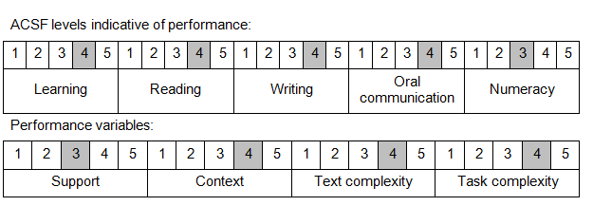

Further information on ACSF and the foundation skills underpinning this unit can be found in the Foundation Skills Guide on the GSA website.

Unit Mapping Information
This unit supersedes and is equivalent to PSPSEC404A Conduct personnel security assessments.

Links
Companion Volume implementation guides are found in VETNet - https://vetnet.gov.au/Pages/TrainingDocs.aspx?q=bebbece7-ff48-4d2c-8876-405679019623
Companion Volume implementation guides are found in VETNet - https://vetnet.gov.au/Pages/TrainingDocs.aspx?q=bebbece7-ff48-4d2c-8876-405679019623
Companion Volume implementation guides are found in VETNet - https://vetnet.gov.au/Pages/TrainingDocs.aspx?q=bebbece7-ff48-4d2c-8876-405679019623
Companion Volume implementation guides are found in VETNet - https://vetnet.gov.au/Pages/TrainingDocs.aspx?q=bebbece7-ff48-4d2c-8876-405679019623

