PSPSEC007 Develop and advise on government security procedures
Release: 1

PSPSEC007 Develop and advise on government security procedures

Modification History
Release | Comments
1 | This unit was released in PSP Public Sector Training Package release 1.0 and meets the Standards for Training Packages.  This unit supersedes and is equivalent to PSPSEC403A Develop and advise on government security procedures.  - Unit code updated  - Content and formatting updated to comply with new standards  - All PC transitioned from passive to active voice  - PC 2.1 and 2.2 merged, PC 4.2 removed

Application
This unit describes the skills required to interpret security policy and legislation, analyse security related data, develop procedures and provide advice on government security matters.
This unit applies to those working in the policy development division of the organisation.
The skills and knowledge described in this unit must be applied within the legislative, regulatory and policy environment in which they are carried out. Organisational policies and procedures must be consulted and adhered to, particularly those related to policy development and implementation.
Those undertaking this unit would generally work independently and as part of a team using support resources as required. They would perform complex tasks in a range of familiar and unfamiliar contexts.
No licensing, legislative or certification requirements apply to unit at the time of publication.

Competency Field
Security

Elements and Performance Criteria
ELEMENTS | PERFORMANCE CRITERIA
Elements describe the essential outcomes | Performance criteria describe the performance needed to demonstrate achievement of the element. Where bold italicised text is used, further information is detailed in the range of conditions section.
1. Interpret security policy and legislation | 1.1 Identify and analyse legislation impacting on security policy and procedures.  1.2 Analyse the organisation’s security policy in relation to risk identification, security management and security incidents.  1.3 Confirm policy intent and identify and review existing procedures for consistency.
2. Analyse security related data | 2.1 Collect and analyse data and confirm its integrity.  2.2 Identify outcomes and trends that need to be addressed through security procedures.  2.3 Determine any changes in organisational circumstances and identify related security procedures.
3. Develop procedures | 3.1 Identify intended audience/s for procedures and determine language style, structure and format accordingly.  3.2 Develop security procedures to reflect changes in circumstances.  3.3 Develop procedures in consultation with security plan developer/s, end users and approval personnel.  3.4 Submit and gain approval for procedures.
4. Provide advice on government security matters | 4.1 Provide information and advice on security procedures and related legislation, regulations, standards and guidelines.  4.2 Consider intended use and consequences of advice and communicate in a manner that addresses the requirements of stakeholders.  4.3 Check documentation provided to ensure it supports the information and advice given.

Foundation Skills
The foundation skills demands of this unit have been mapped for alignment with the Australian Core Skills Framework (ACSF). The following tables outline the performance levels indicated for successful attainment of the unit.

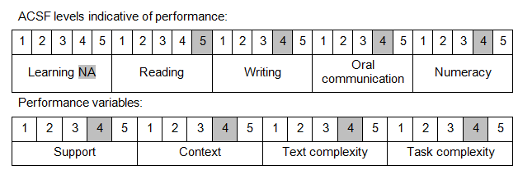

Further information on ACSF and the foundation skills underpinning this unit can be found in the Foundation Skills Guide on the GSA website.

Unit Mapping Information
This unit supersedes and is equivalent to PSPSEC403A Develop and advise on government security procedures.

Links
Companion Volume implementation guides are found in VETNet - https://vetnet.gov.au/Pages/TrainingDocs.aspx?q=bebbece7-ff48-4d2c-8876-405679019623
Companion Volume implementation guides are found in VETNet - https://vetnet.gov.au/Pages/TrainingDocs.aspx?q=bebbece7-ff48-4d2c-8876-405679019623
Companion Volume implementation guides are found in VETNet - https://vetnet.gov.au/Pages/TrainingDocs.aspx?q=bebbece7-ff48-4d2c-8876-405679019623
Companion Volume implementation guides are found in VETNet - https://vetnet.gov.au/Pages/TrainingDocs.aspx?q=bebbece7-ff48-4d2c-8876-405679019623

