PSPSEC004 Undertake information technology security audits
Release: 1

PSPSEC004 Undertake information technology security audits

Modification History
Release | Comments
1 | This unit was released in PSP Public Sector Training Package release 1.0 and meets the Standards for Training Packages.  This unit supersedes and is equivalent to PSPSEC304A Undertake information technology security audits.  - Unit code updated  - Content and formatting updated to comply with new standards  - All PC transitioned from passive to active voice  - PC 1.1 and 1.2. PC 1.5 and 1.6, PC 2.4 and 2.5, PC 3.1 and 3.2 merged

Application
This unit describes the skills required to plan and conduct an information technology security audit and report on security findings.
This unit applies to those working in a role where they have responsibilities under the organisation’s security plan.
The skills and knowledge described in this unit must be applied within the legislative, regulatory and policy environment in which they are carried out. Organisational policies and procedures must be consulted and adhered to.
Those undertaking this unit would generally work independently and as part of a team using support resources as required. They would perform complex tasks in a range of familiar and unfamiliar contexts.
No licensing, legislative or certification requirements apply to unit at the time of publication.

Competency Field
Security

Elements and Performance Criteria
ELEMENTS | PERFORMANCE CRITERIA
Elements describe the essential outcomes | Performance criteria describe the performance needed to demonstrate achievement of the element. Where bold italicised text is used, further information is detailed in the range of conditions section.
1. Plan security audit | 1.1 Identify the scope and objectives of the audit and prepare an audit plan to meet the objectives.  1.2 Identify the organisation’s information systems to be included in the audit plan.  1.3 Advise appropriate personnel of the audit plan and its requirements.  1.4 Identify and prioritise possible sources of security risk and prepare an audit checklist.
2. Conduct security audit | 2.1 Identify and analyse systems, procedures, records and documents.  2.2 Conduct audit in accordance with the audit plan.  2.3 Record audit activities.  2.4 Identify situations requiring specialist input or referral to other areas and act on referral.
3. Report on security findings | 3.1 Maintain audit records and prepare audit reports.  3.2 Produce report including background, scope, outcomes and recommendations.  3.3 Use language and style to suit the audience and in line with organisational requirements for accuracy and timeliness.  3.4 Support recommendations with evidence and highlight actions identifying person/s responsible for implementation.

Foundation Skills
The foundation skills demands of this unit have been mapped for alignment with the Australian Core Skills Framework (ACSF). The following tables outline the performance levels indicated for successful attainment of the unit.

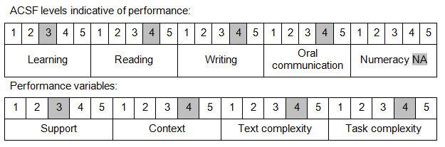

Further information on ACSF and the foundation skills underpinning this unit can be found in the Foundation Skills Guide on the GSA website.

Unit Mapping Information
This unit supersedes and is equivalent to PSPSEC304A Undertake information technology security audits.

Links
Companion Volume implementation guides are found in VETNet - https://vetnet.gov.au/Pages/TrainingDocs.aspx?q=bebbece7-ff48-4d2c-8876-405679019623
Companion Volume implementation guides are found in VETNet - https://vetnet.gov.au/Pages/TrainingDocs.aspx?q=bebbece7-ff48-4d2c-8876-405679019623
Companion Volume implementation guides are found in VETNet - https://vetnet.gov.au/Pages/TrainingDocs.aspx?q=bebbece7-ff48-4d2c-8876-405679019623
Companion Volume implementation guides are found in VETNet - https://vetnet.gov.au/Pages/TrainingDocs.aspx?q=bebbece7-ff48-4d2c-8876-405679019623

