PSPSEC002 Respond to government security incidents
Release: 1

PSPSEC002 Respond to government security incidents

Modification History
Release | Comments
1 | This unit was released in PSP Public Sector Training Package release 1.0 and meets the Standards for Training Packages.  This unit supersedes and is equivalent to PSPSEC302A Respond to government security incidents.  - Unit code updated  - Content and formatting updated to comply with new standards  - All PC transitioned from passive to active voice  - PC 1.1 and 1.2, PC 2.1 and 2.2 merged

Application
This unit describes the skills required to access and advise on security incidents and plan an incident response within the limits of role and responsibility.
This unit applies to those working in a security role where they are expected to identify, manage, finalise and recommend actions if required.
The skills and knowledge described in this unit must be applied within the legislative, regulatory and policy environment in which they are carried out. Organisational policies and procedures must be consulted and adhered to.
Those undertaking this unit would generally work independently and/or as part of a team, using support resources as required. They would perform routine tasks in a range of familiar and unfamiliar contexts.
No licensing, legislative or certification requirements apply to unit at the time of publication.

Competency Field
Security

Elements and Performance Criteria
ELEMENTS | PERFORMANCE CRITERIA
Elements describe the essential outcomes | Performance criteria describe the performance needed to demonstrate achievement of the element. Where bold italicised text is used, further information is detailed in the range of conditions section.
1. Assess and advise on security incidents | 1.1 Identify security incident and respond, according to seriousness of the incident.  1.2 Conduct preliminary assessment that considers the nature of the breach, level of risk and likely consequences.  1.3 Determine limitations of own expertise and refer to more specialised personnel as required.  1.4 Maintain records relating to the incident.
2. Plan incident response | 2.1 Identify, collect and assess evidence to determine risk factor.  2.2 Recommend action appropriate to the level of seriousness of the incident.  2.3 Identify and document changes required in security policy as a result of the incident.  2.4 Advise relevant agencies of the incident.  2.5 Prepare a final report incorporating background to the incident, action taken, interview statements, outcomes, summary of findings and recommended actions.

Foundation Skills
The foundation skills demands of this unit have been mapped for alignment with the Australian Core Skills Framework (ACSF). The following tables outline the performance levels indicated for successful attainment of the unit.

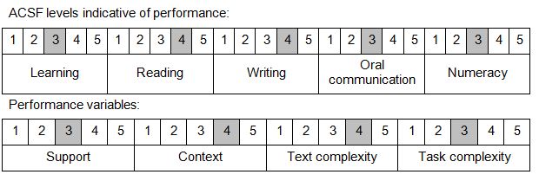

Further information on ACSF and the foundation skills underpinning this unit can be found in the Foundation Skills Guide on the GSA website.

Unit Mapping Information
This unit supersedes and is equivalent to PSPSEC302A Respond to government security incidents.

Links
Companion Volume implementation guides are found in VETNet - https://vetnet.gov.au/Pages/TrainingDocs.aspx?q=bebbece7-ff48-4d2c-8876-405679019623
Companion Volume implementation guides are found in VETNet - https://vetnet.gov.au/Pages/TrainingDocs.aspx?q=bebbece7-ff48-4d2c-8876-405679019623
Companion Volume implementation guides are found in VETNet - https://vetnet.gov.au/Pages/TrainingDocs.aspx?q=bebbece7-ff48-4d2c-8876-405679019623
Companion Volume implementation guides are found in VETNet - https://vetnet.gov.au/Pages/TrainingDocs.aspx?q=bebbece7-ff48-4d2c-8876-405679019623

