PSPINV003 Finalise an investigation
Release: 1

PSPINV003 Finalise an investigation

Modification History
Release | Comments
1 | This unit was released in PSP Public Sector Training Package release 1.0 and meets the Standards for Training Packages.

Application
This unit describes the skills required to complete, review and report on the results of an investigation. It includes finalising the investigation, handling complaints and appeals, preparing an investigation report and using investigation outcomes.
This unit applies to those working in a range of regulatory work environments comprising gathering, managing and interpreting documentary evidence to determine appropriate responses including reporting and acting on investigation outcomes.
The skills and knowledge described in this unit must be applied within the legislative, regulatory and policy environment in which they are carried out. Organisational policies and procedures must be consulted and adhered to, particularly those related to WHS and environment in the context of investigations.
Those undertaking this unit would work independently using support from a range of established resources to perform complex tasks in a range of contexts, including some that are unfamiliar and/or unpredictable.
No licensing, legislative or certification requirements apply to unit at the time of publication.

Competency Field
Investigation

Elements and Performance Criteria
ELEMENTS | PERFORMANCE CRITERIA
Elements describe the essential outcomes | Performance criteria describe the performance needed to demonstrate achievement of the element. Where bold italicised text is used, further information is detailed in the range of conditions section.
1. Address investigation outcomes | 1.1 Complete documentation if no breach has occurred or no action is to be taken, including reasons and justification.  1.2 Prepare and submit a record of the investigation and consequent recommendations for action.  1.3 Respond to complaints, appeals and the potential role of the ombudsman.  1.4 Advise relevant personnel on the outcome of the investigation.  1.5 Make recommendation for referral to another organisation as required and document for the organisation’s information.
2. Report findings | 2.1 Prepare finalisation report in relation to the findings and submission of evidence, with recommendations for subsequent action if relevant.  2.2 Prepare report and refer to relevant personnel for further action.
3. Finalise investigation | 3.1 Undertake self-assessment of the conduct of the investigation and provide verbal and written briefings.  3.2 Inform relevant external organisations of outcomes and document this action.  3.3 Update organisational systems regularly, contributing investigation results for the development of statistics, trends and precedents.

Foundation Skills
The foundation skills demands of this unit have been mapped for alignment with the Australian Core Skills Framework (ACSF). The following tables outline the performance levels indicated for successful attainment of the unit.

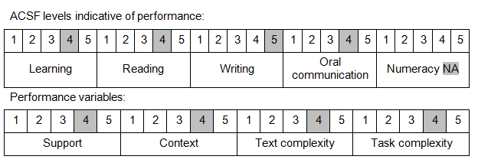

Further information on ACSF and the foundation skills underpinning this unit can be found in the Foundation Skills Guide on the GSA website.

Unit Mapping Information
No equivalent unit.

Links
Companion Volume implementation guides are found in VETNet - https://vetnet.gov.au/Pages/TrainingDocs.aspx?q=bebbece7-ff48-4d2c-8876-405679019623
Companion Volume implementation guides are found in VETNet - https://vetnet.gov.au/Pages/TrainingDocs.aspx?q=bebbece7-ff48-4d2c-8876-405679019623
Companion Volume implementation guides are found in VETNet - https://vetnet.gov.au/Pages/TrainingDocs.aspx?q=bebbece7-ff48-4d2c-8876-405679019623
Companion Volume implementation guides are found in VETNet - https://vetnet.gov.au/Pages/TrainingDocs.aspx?q=bebbece7-ff48-4d2c-8876-405679019623

