PSPINV001 Plan and initiate an investigation
Release: 1

PSPINV001 Plan and initiate an investigation

Modification History
Release | Comments
1 | This unit was released in PSP Public Sector Training Package release 1.0 and meets the Standards for Training Packages.

Application
This unit describes the skills required to identify and confirm possible non-compliance, and plan and initiate a subsequent investigation. It includes planning and activating evidence collection, identifying witnesses and persons of interest.
This unit applies to those working in a range of regulatory work environments involving gathering and managing physical or documentary evidence from a range of sources.
The skills and knowledge described in this unit must be applied within the legislative, regulatory and policy environment in which they are carried out. Organisational policies and procedures must be consulted and adhered to, particularly those related to WHS in the context of investigations.
Those undertaking this unit would work independently using support from a range of established resources to perform complex tasks in a range of contexts, including some that are unfamiliar and/or unpredictable.
No licensing, legislative or certification requirements apply to unit at the time of publication.

Competency Field
Investigation

Elements and Performance Criteria
ELEMENTS | PERFORMANCE CRITERIA
Elements describe the essential outcomes | Performance criteria describe the performance needed to demonstrate achievement of the element. Where bold italicised text is used, further information is detailed in the range of conditions section.
1. Initiate preliminary investigation to confirm non-compliance | 1.1 Assess information, confirm likely non-compliance and if matter under investigation falls within jurisdiction.  1.2 Prioritise importance and urgency of the matter for action.  1.3 Initiate documentation for investigation of alleged matter.
2. Plan investigation | 2.1 Determine the objectives of the investigation and obtain necessary resources to conduct the investigation.  2.2 Identify and plan for risks associated with the investigation including sensitivities that might affect the organisation.  2.3 Select methods to achieve the investigation’s objectives.  2.4 Identify timelines and prioritise tasks.  2.5 Confirm and initiate communication and case management requirements.  2.6 Record investigation planning.  2.7 Obtain approval to commence investigation.
3. Initiate investigation | 3.1 Implement evidence recording process.  3.2 Identify, locate and contact possible witnesses to request information.  3.3 Identify and locate responsible parties and record their particulars.  3.4 Contact responsible parties for interview and inform them of the nature of the investigation as required by law.  3.5 Research evidence requirements to establish the type and standard of evidence and necessary resources according to the size of investigation and nature of the offence.  3.6 Select and initiate investigative techniques.

Foundation Skills
The foundation skills demands of this unit have been mapped for alignment with the Australian Core Skills Framework (ACSF). The following tables outline the performance levels indicated for successful attainment of the unit.

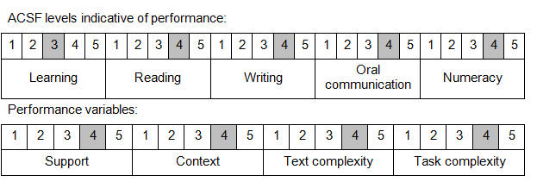

Further information on ACSF and the foundation skills underpinning this unit can be found in the Foundation Skills Guide on the GSA website.

Unit Mapping Information
No equivalent unit.

Links
Companion Volume implementation guides are found in VETNet - https://vetnet.gov.au/Pages/TrainingDocs.aspx?q=bebbece7-ff48-4d2c-8876-405679019623
Companion Volume implementation guides are found in VETNet - https://vetnet.gov.au/Pages/TrainingDocs.aspx?q=bebbece7-ff48-4d2c-8876-405679019623
Companion Volume implementation guides are found in VETNet - https://vetnet.gov.au/Pages/TrainingDocs.aspx?q=bebbece7-ff48-4d2c-8876-405679019623
Companion Volume implementation guides are found in VETNet - https://vetnet.gov.au/Pages/TrainingDocs.aspx?q=bebbece7-ff48-4d2c-8876-405679019623

