PSPGEN023 Deliver and monitor service to clients
Release: 1

PSPGEN023 Deliver and monitor service to clients

Modification History
Release | Comments
1 | This unit was released in PSP Public Sector Training Package release 1.0 and meets the Standards for Training Packages.  This unit supersedes and is equivalent to PSPGOV402B Deliver and monitor service to clients.  - Unit code updated  - Content and formatting updated to comply with the new standards  - All PC transitioned from passive to active voice

Application
This unit describes the skills required to identify client needs, deliver a service, monitor through feedback and then review the service.
This unit applies to those working in public sector roles but may be applied to anyone working in a similar organisational context.
The skills and knowledge described in this unit must be applied within the legislative, regulatory and policy environment in which they are carried out. Organisational policies and procedures must be consulted and adhered to.
Those undertaking this unit would be working under supervision, performing routine tasks in a range of familiar contexts.
No licensing, legislative or certification requirements apply to unit at the time of publication.

Competency Field
General

Elements and Performance Criteria
ELEMENTS | PERFORMANCE CRITERIA
Elements describe the essential outcomes | Performance criteria describe the performance needed to demonstrate achievement of the element. Where bold italicised text is used, further information is detailed in the range of conditions section.
1. Identify and define client needs | 1.1 Identify services required by client, ensuring needs of clients are recognised and addressed.  1.2 Identify potential difficulties and address or refer for recommended action.
2. Deliver client service | 2.1 Respond to client enquiries.  2.2 Tailor communication to the situation and the client’s specific needs.  2.3 Negotiate or use conflict resolution techniques to resolve difficult situations, or refer where appropriate.  2.4 Undertake remedial actions for clients with specific needs or in potential areas of difficulty.  2.5 Use accountability measures, including the organisational client service charter, client service records, grievance procedures and/or external review.
3. Monitor and improve client service delivery | 3.1 Monitor service delivery and use feedback to and from colleagues to improve personal service.  3.2 Convey changes in policies and procedures that impact upon client relations.  3.3 Seek advice and assistance where necessary, to deal with client service issues, meeting changing needs and achieving service potential.
4. Review client service | 4.1 Monitor procedural aspects of service delivery and maintain records.  4.2 Seek client feedback and propose changes in response to feedback on service development and delivery.  4.3 Carry out modifications to client service within limits and area of responsibility.

Foundation Skills
The foundation skills demands of this unit have been mapped for alignment with the Australian Core Skills Framework (ACSF). The following tables outline the performance levels indicated for successful attainment of the unit.

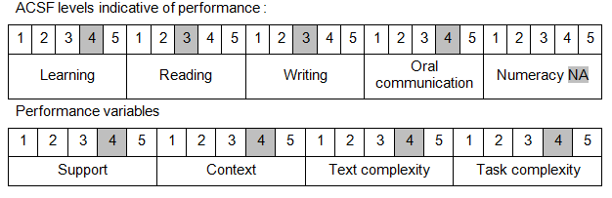

Further information on ACSF and the foundation skills underpinning this unit can be found in the Foundation Skills Guide on the GSA website.

Unit Mapping Information
This unit supersedes and is equivalent to PSPGOV402B Deliver and monitor service to clients.

Links
Companion Volume implementation guides are found in VETNet - https://vetnet.gov.au/Pages/TrainingDocs.aspx?q=bebbece7-ff48-4d2c-8876-405679019623
Companion Volume implementation guides are found in VETNet - https://vetnet.gov.au/Pages/TrainingDocs.aspx?q=bebbece7-ff48-4d2c-8876-405679019623
Companion Volume implementation guides are found in VETNet - https://vetnet.gov.au/Pages/TrainingDocs.aspx?q=bebbece7-ff48-4d2c-8876-405679019623
Companion Volume implementation guides are found in VETNet - https://vetnet.gov.au/Pages/TrainingDocs.aspx?q=bebbece7-ff48-4d2c-8876-405679019623

