PSPETH001 Uphold the values and principles of public service
Release: 1

PSPETH001 Uphold the values and principles of public service

Modification History
Release | Comments
1 | This unit was released in PSP Public Sector Training Package release 1.0 and meets the Standards for Training Packages.  This unit supersedes and is equivalent to PSPETHC301B Uphold the values and principles of public service.  - Unit code updated  - Content and formatting updated to comply with new standards  - All PC transitioned from passive to active voice

Application
This unit describes the skills required to demonstrate ethical conduct required of those in public service. It includes applying ethical standards and dealing with ethical problems.
This unit applies to those working in public sector roles but may be applied to anyone working in a similar organisational context.
The skills and knowledge described in this unit must be applied within the legislative, regulatory and policy environment in which they are carried out. Organisational policies and procedures must be consulted and adhered to.
Those undertaking this unit will generally work independently and as part of a team. They would perform routine tasks in a range of familiar contexts.
No licensing, legislative or certification requirements apply to unit at the time of publication.

Competency Field
Ethics

Elements and Performance Criteria
ELEMENTS | PERFORMANCE CRITERIA
Elements describe the essential outcomes | Performance criteria describe the performance needed to demonstrate achievement of the element. Where bold italicised text is used, further information is detailed in the range of conditions section.
1. Apply ethical standards
  1.1 Review interpretation of ethical values and principles with senior staff to ensure accuracy.
  1.2 Apply ethical standards when preparing verbal and written advice and reports.
  1.3 Use public resources ethically, ensuring conflicts of interest are declared, addressed and documented.
  1.4 Apply ethical standards in all relationships with the public, suppliers and business contacts.
2. Deal with ethical problems | 2.1 Resolve ethical problems or refer as required.  2.2 Document all decision-making processes used and record outcomes.  2.3 Implement preventative strategies.  2.4 Report unethical conduct.

Foundation Skills
The foundation skills demands of this unit have been mapped for alignment with the Australian Core Skills Framework (ACSF). The following tables outline the performance levels indicated for successful attainment of the unit.

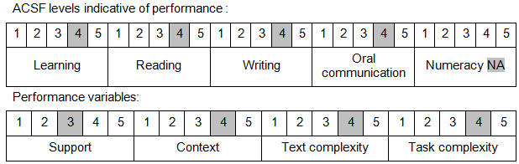

Further information on ACSF and the foundation skills underpinning this unit can be found in the Foundation Skills Guide on the GSA website.

Unit Mapping Information
This unit supersedes and is equivalent to PSPETHC301B Uphold the values and principles of public service.

Links
Companion Volume implementation guides are found in VETNet - https://vetnet.gov.au/Pages/TrainingDocs.aspx?q=bebbece7-ff48-4d2c-8876-405679019623
Companion Volume implementation guides are found in VETNet - https://vetnet.gov.au/Pages/TrainingDocs.aspx?q=bebbece7-ff48-4d2c-8876-405679019623
Companion Volume implementation guides are found in VETNet - https://vetnet.gov.au/Pages/TrainingDocs.aspx?q=bebbece7-ff48-4d2c-8876-405679019623
Companion Volume implementation guides are found in VETNet - https://vetnet.gov.au/Pages/TrainingDocs.aspx?q=bebbece7-ff48-4d2c-8876-405679019623

