PSPCRT025 Manage court practice and process
Release: 1

PSPCRT025 Manage court practice and process

Modification History
Release | Comments
1 | This unit was released in PSP Public Sector Training Package release 1.0 and meets the Standards for Training Packages.  This unit supersedes and is equivalent to PSPCRT601B Manage court practice and process.  - Unit code updated  - Content and formatting updated to comply with new standards  - All PC transitioned from passive to active voice

Application
This unit describes the skills required to implement legislative change as it applies to courts, in conjunction with judicial officers. It includes providing advice, modifying systems and procedures, fostering commitment to changed systems and procedures.
This unit applies to those working within the court system operating under procedures set by the court.
The skills and knowledge described in this unit must be applied within the legislative, regulatory and policy environment in which they are carried out. Organisational policies and procedures must be consulted and adhered to, particularly those set by the court.
Those undertaking this unit would generally work independently with occasional supervisory responsibilities. They would perform complex tasks in a range of familiar and unfamiliar contexts.
No licensing, legislative or certification requirements apply to unit at the time of publication.

Competency Field
Courts

Elements and Performance Criteria
ELEMENTS | PERFORMANCE CRITERIA
Elements describe the essential outcomes | Performance criteria describe the performance needed to demonstrate achievement of the element. Where bold italicised text is used, further information is detailed in the range of conditions section.
1. Provide information and options on rules and legislation | 1.1 Establish consultative links with other agencies, organisations and the public having regular dealings with the court.  1.2 Provide consulting and advisory services on issues relating to the operation of the court.  1.3 Interpret, explain and apply legislation in the context of specific as well as general practice and procedures.  1.4 Interpret and assess the impact of legislative change for its effect on practice and procedures, and advise on its application.  1.5 Provide input to the development of organisational policy and procedures to implement changes in legislation.
2. Modify systems and procedures | 2.1 Evaluate policies, procedures and practices, identify and analyse problems.  2.2 Review systems and methods of work and manage staffing levels to achieve agreed objectives.  2.3 Undertake consultation with a range of stakeholders to improve practice and procedures.  2.4 Identify, assess and develop alternative approaches, strategies and solutions.  2.5 Design new or improved systems and procedures to comply with legislation, determine rules and resource implications of changes.
3. Foster commitment to changed systems and procedures | 3.1 Foster a positive attitude to changed systems and procedures using a range of strategies.  3.2 Provide information and strategies to staff on the requirements for effective change management and any transition arrangements.  3.3 Obtain and apply resources required to implement procedures within court administration.  3.4 Use leadership strategies to assist others to deal with ambiguity and adapt to change.

Foundation Skills
The foundation skills demands of this unit have been mapped for alignment with the Australian Core Skills Framework (ACSF). The following tables outline the performance levels indicated for successful attainment of the unit.

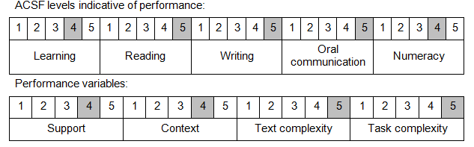

Further information on ACSF and the foundation skills underpinning this unit can be found in the Foundation Skills Guide on the GSA website.

Unit Mapping Information
This unit supersedes and is equivalent to PSPCRT601B Manage court practice and process.

Links
Companion Volume implementation guides are found in VETNet - https://vetnet.gov.au/Pages/TrainingDocs.aspx?q=bebbece7-ff48-4d2c-8876-405679019623
Companion Volume implementation guides are found in VETNet - https://vetnet.gov.au/Pages/TrainingDocs.aspx?q=bebbece7-ff48-4d2c-8876-405679019623
Companion Volume implementation guides are found in VETNet - https://vetnet.gov.au/Pages/TrainingDocs.aspx?q=bebbece7-ff48-4d2c-8876-405679019623
Companion Volume implementation guides are found in VETNet - https://vetnet.gov.au/Pages/TrainingDocs.aspx?q=bebbece7-ff48-4d2c-8876-405679019623

