PSPCRT023 Perform quasi-judicial functions
Release: 1

PSPCRT023 Perform quasi-judicial functions

Modification History
Release | Comments
1 | This unit was released in PSP Public Sector Training Package release 1.0 and meets the Standards for Training Packages.  This unit supersedes and is equivalent to PSPCRT506B Perform quasi-judicial functions.  - Unit code updated  - Content and formatting updated to comply with new standards  - All PC transitioned from passive to active voice  - PC 2.4 and 2.5, PC 3.3 and 3.4 merged

Application
This unit describes the skills required to perform quasi-judicial functions as prescribed by legislation and Rules of Court. It includes advising on rules and legislation, settling court orders and presiding in prescribed matters under specified court rules and practice.
This unit applies to those working as court officials within the court system operating under procedures set by the court.
The skills and knowledge described in this unit must be applied within the legislative, regulatory and policy environment in which they are carried out. Organisational policies and procedures must be consulted and adhered to, particularly those set by the court.
Those undertaking this unit would generally work independently with supervisory responsibilities. They would perform complex tasks in a range of familiar and unfamiliar contexts.
No licensing, legislative or certification requirements apply to unit at the time of publication.

Competency Field
Courts

Elements and Performance Criteria
ELEMENTS | PERFORMANCE CRITERIA
Elements describe the essential outcomes | Performance criteria describe the performance needed to demonstrate achievement of the element. Where bold italicised text is used, further information is detailed in the range of conditions section.
1. Provide information and options on rules and legislation | 1.1 Provide interpretation of rules and legislation in the context of specific and general practice and procedure.  1.2 Assess severity of urgent matters and determine course of procedure.  1.3 Determine intent of legislation and provide advice.
2. Settle orders | 2.1 Interpret and amend draft orders according to record of outcome.  2.2 Liaise with legal representatives, judicial officers and associates regarding discrepancies in interpretation of the orders made.  2.3 Prepare final orders made at hearings.  2.4 Sign and seal completed orders and settle cases.
3. Preside in prescribed matters | 3.1 Assess case flow requirements in accordance with legislation, rules, court load, natural justice and defined criteria to ensure that matters proceed in line with timeframes and guidelines of case-flow management.  3.2 Facilitate discussion to explain the reason for a hearing and to achieve settlement of the matter between the parties.  3.3 Confirm issues and discuss options providing direction and guidance to the parties.  3.4 Make decisions or orders to settle the matter and ensure a fair and equitable outcome in accordance with the principles of natural justice.  3.5 Expedite listing and hearing for matters proceeding to further hearing.

Foundation Skills
The foundation skills demands of this unit have been mapped for alignment with the Australian Core Skills Framework (ACSF). The following tables outline the performance levels indicated for successful attainment of the unit.

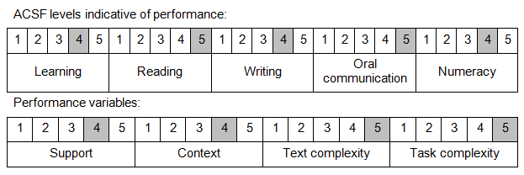
Further information on ACSF and the foundation skills underpinning this unit can be found in the Foundation Skills Guide on the GSA website.

Unit Mapping Information
This unit supersedes and is equivalent to PSPCRT506B Perform quasi-judicial functions.

Links
Companion Volume implementation guides are found in VETNet - https://vetnet.gov.au/Pages/TrainingDocs.aspx?q=bebbece7-ff48-4d2c-8876-405679019623
Companion Volume implementation guides are found in VETNet - https://vetnet.gov.au/Pages/TrainingDocs.aspx?q=bebbece7-ff48-4d2c-8876-405679019623
Companion Volume implementation guides are found in VETNet - https://vetnet.gov.au/Pages/TrainingDocs.aspx?q=bebbece7-ff48-4d2c-8876-405679019623
Companion Volume implementation guides are found in VETNet - https://vetnet.gov.au/Pages/TrainingDocs.aspx?q=bebbece7-ff48-4d2c-8876-405679019623

