PSPCRT021 Carry out possessions and evictions
Release: 1

PSPCRT021 Carry out possessions and evictions

Modification History
Release | Comments
1 | This unit was released in PSP Public Sector Training Package release 1.0 and meets the Standards for Training Packages.  This unit supersedes and is equivalent to PSPCRT504C Carry out possessions and evictions.  - Unit code updated  - Content and formatting updated to comply with new standards  - All PC transitioned from passive to active voice  - 1 new PC in Element 1  - PC 2.4 and 2.5 removed

Application
This unit describes the skills required to carry out possessions and evictions under writs and warrants. It includes completing preliminary requirements prior to operation, using relevant protocols to carry out possessions and evictions and completing administrative requirements.
This unit applies to those working within the court system operating under procedures set by the court.
The skills and knowledge described in this unit must be applied within the legislative, regulatory and policy environment in which they are carried out. Organisational policies and procedures must be consulted and adhered to, particularly those set by the court.
Those undertaking this unit would generally work independently with occasional supervisory responsibilities. They would perform complex tasks in a broad range of often unpredictable contexts.
No licensing, legislative or certification requirements apply to unit at the time of publication.

Competency Field
Courts

Elements and Performance Criteria
ELEMENTS | PERFORMANCE CRITERIA
Elements describe the essential outcomes | Performance criteria describe the performance needed to demonstrate achievement of the element. Where bold italicised text is used, further information is detailed in the range of conditions section.
1. Complete preliminary requirements prior to carrying out possessions and evictions | 1.1 Check writs or warrants prior to execution to confirm validity, expiry date and detailed requirements.  1.2 Prepare and deliver notices to vacate to the occupant.  1.3 Confirm possession and/or eviction dates and times with the occupant and other personnel to be present and outline their responsibilities.  1.4 Conduct risk assessments to identify potential safety issues, and arrange assistance according to the level of identified risk.  1.5 Make arrangements for payment of possession and/or eviction fees.  1.6 Reschedule the possession and/or eviction if the plaintiffs or their representatives are unable to attend.
2. Use relevant protocols to conduct possessions and evictions | 2.1 Attend location and request all persons on the premises without rights to leave.  2.2 Remove occupants with force and with assistance where required, if request to leave is refused, and deal with contingencies.  2.3 Give possession to plaintiffs or their representatives in accordance with conditions of writ or warrant, once all persons, goods and chattels are outside the property line.
3. Complete administrative requirements | 3.1 Obtain signatures of plaintiffs or their representatives on a receipt of possession, and retain with the writ or warrant.  3.2 Provide receipt of payment of possession or eviction fees.  3.3 Complete organisational records and reporting requirements.

Foundation Skills
The foundation skills demands of this unit have been mapped for alignment with the Australian Core Skills Framework (ACSF). The following tables outline the performance levels indicated for successful attainment of the unit.

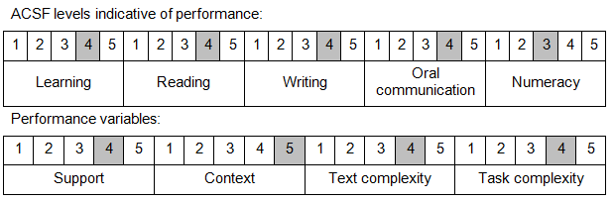

Further information on ACSF and the foundation skills underpinning this unit can be found in the Foundation Skills Guide on the GSA website.

Unit Mapping Information
This unit supersedes and is equivalent to PSPCRT504C Carry out possessions and evictions.

Links
Companion Volume implementation guides are found in VETNet - https://vetnet.gov.au/Pages/TrainingDocs.aspx?q=bebbece7-ff48-4d2c-8876-405679019623
Companion Volume implementation guides are found in VETNet - https://vetnet.gov.au/Pages/TrainingDocs.aspx?q=bebbece7-ff48-4d2c-8876-405679019623
Companion Volume implementation guides are found in VETNet - https://vetnet.gov.au/Pages/TrainingDocs.aspx?q=bebbece7-ff48-4d2c-8876-405679019623
Companion Volume implementation guides are found in VETNet - https://vetnet.gov.au/Pages/TrainingDocs.aspx?q=bebbece7-ff48-4d2c-8876-405679019623

