PSPCRT018 Perform court duties
Release: 1

PSPCRT018 Perform court duties

Modification History
Release | Comments
1 | This unit was released in PSP Public Sector Training Package release 1.0 and meets the Standards for Training Packages.  This unit supersedes and is equivalent to PSPCRT501C Perform court duties.  - Unit code updated  - Content and formatting updated to comply with new standards  - All PC transitioned from passive to active voice

Application
This unit describes the skills required to perform duties in a range of courts or jurisdictions. It includes confirming the requirements of the court and completing court documentation.
This unit applies to those working within the court system operating under procedures set by the court.
The skills and knowledge described in this unit must be applied within the legislative, regulatory and policy environment in which they are carried out. Organisational policies and procedures must be consulted and adhered to, particularly those set by the court.
Those undertaking this unit would generally work independently with occasional supervisory responsibilities. They would perform complex tasks in a range of familiar and unfamiliar contexts.
No licensing, legislative or certification requirements apply to unit at the time of publication.

Competency Field
Courts

Elements and Performance Criteria
ELEMENTS | PERFORMANCE CRITERIA
Elements describe the essential outcomes | Performance criteria describe the performance needed to demonstrate achievement of the element. Where bold italicised text is used, further information is detailed in the range of conditions section.
1. Confirm court requirements | 1.1 Identify court or jurisdiction and confirm sittings.  1.2 Identify types of proceedings and matters to be heard and confirm special requirements with presiding official.  1.3 Identify parties to be in attendance according to requirements specific to the court and the matters to be heard.  1.4 Identify court layout and equipment and technology requirements according to the requirements of the court and legal practitioners.
2. Undertake activities as part of court duties | 2.1 Perform court duties, and communicate using relevant terminology.  2.2 Perform duties specific to court’s jurisdiction.  2.3 Distribute diaries to other centres.
3. Complete court documentation | 3.1 Complete records prior to court commencement and/or at conclusion.  3.2 Identify and complete documentary requirements of court outcomes.

Foundation Skills
The foundation skills demands of this unit have been mapped for alignment with the Australian Core Skills Framework (ACSF). The following tables outline the performance levels indicated for successful attainment of the unit.

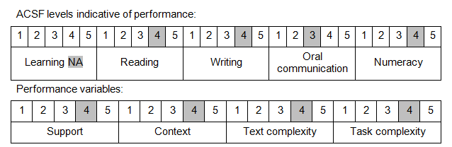

Further information on ACSF and the foundation skills underpinning this unit can be found in the Foundation Skills Guide on the GSA website.

Unit Mapping Information
This unit supersedes and is equivalent to PSPCRT501C Perform court duties.

Links
Companion Volume implementation guides are found in VETNet - https://vetnet.gov.au/Pages/TrainingDocs.aspx?q=bebbece7-ff48-4d2c-8876-405679019623
Companion Volume implementation guides are found in VETNet - https://vetnet.gov.au/Pages/TrainingDocs.aspx?q=bebbece7-ff48-4d2c-8876-405679019623
Companion Volume implementation guides are found in VETNet - https://vetnet.gov.au/Pages/TrainingDocs.aspx?q=bebbece7-ff48-4d2c-8876-405679019623
Companion Volume implementation guides are found in VETNet - https://vetnet.gov.au/Pages/TrainingDocs.aspx?q=bebbece7-ff48-4d2c-8876-405679019623

