PSPCRT016 Administer alternative dispute-resolution proceedings
Release: 1

PSPCRT016 Administer alternative dispute-resolution proceedings

Modification History
Release | Comments
1 | This unit was released in PSP Public Sector Training Package release 1.0 and meets the Standards for Training Packages.  This unit supersedes and is equivalent to PSPCRT415A Administer alternative dispute-resolution proceedings.  - Unit code updated  - Content and formatting updated to comply with new standards  - All PC transitioned from passive to active voice  - PC 1.4 and 1.5 merged  - PC 3.4 removed

Application
This unit describes the skills required to administer alternative dispute-resolution (ADR) proceedings, including mandatory and voluntary proceedings within the court, or referral to other services. It includes communicating and clarifying information with consideration of client needs and diversity and ensuring compliance with ADR procedures or support ADR processing.
This unit applies to those working within the court system operating under procedures set by the court.
The skills and knowledge described in this unit must be applied within the legislative, regulatory and policy environment in which they are carried out. Organisational policies and procedures must be consulted and adhered to, particularly those set by the court.
Those undertaking this unit would generally work independently with occasional supervisory responsibilities. They would perform complex tasks in a range of familiar and unfamiliar contexts.
No licensing, legislative or certification requirements apply to unit at the time of publication.

Competency Field
Courts

Elements and Performance Criteria
ELEMENTS | PERFORMANCE CRITERIA
Elements describe the essential outcomes | Performance criteria describe the performance needed to demonstrate achievement of the element. Where bold italicised text is used, further information is detailed in the range of conditions section.
1. Arrange compliance with mandatory ADR procedures | 1.1 Explain benefits of ADR procedures and answer client’s questions.  1.2 Explain procedural requirements.  1.3 Identify potential difficulties in arranging delivery of services and address or refer them for action.  1.4 Use negotiation and conflict-resolution skills to gain agreement to arrangements and complete documentation.
2. Refer parties to ADR procedures and services | 2.1 Assess eligibility for access to ADR services and potential circumstances where ADR may not be appropriate and address or refer them for action.  2.2 Identify legislative and other constraints and take into account when advising on appropriate dispute-resolution process.  2.3 Analyse the issues and the parties’ willingness and capability to assess the most suitable resolution process.  2.4 Explain procedural requirements and confirm understanding.  2.5 Explain impact of ADR proceedings on case management.
3. Support ADR processes | 3.1 Outline and implement processes to ensure respect for client’s safety and needs.  3.2 Explain client responsibility and contribution to outcomes and confirm understanding.  3.3 Assist client to prepare for problem solving and negotiation.  3.4 Explain privacy and confidentiality requirements of proceedings.

Foundation Skills
The foundation skills demands of this unit have been mapped for alignment with the Australian Core Skills Framework (ACSF). The following tables outline the performance levels indicated for successful attainment of the unit.
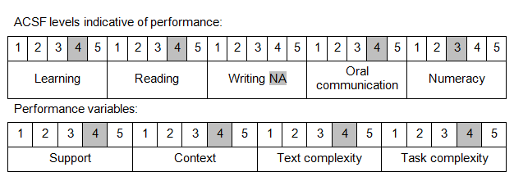

Further information on ACSF and the foundation skills underpinning this unit can be found in the Foundation Skills Guide on the GSA website.

Unit Mapping Information
This unit supersedes and is equivalent to PSPCRT415A Administer alternative dispute-resolution proceedings.

Links
Companion Volume implementation guides are found in VETNet - https://vetnet.gov.au/Pages/TrainingDocs.aspx?q=bebbece7-ff48-4d2c-8876-405679019623
Companion Volume implementation guides are found in VETNet - https://vetnet.gov.au/Pages/TrainingDocs.aspx?q=bebbece7-ff48-4d2c-8876-405679019623
Companion Volume implementation guides are found in VETNet - https://vetnet.gov.au/Pages/TrainingDocs.aspx?q=bebbece7-ff48-4d2c-8876-405679019623
Companion Volume implementation guides are found in VETNet - https://vetnet.gov.au/Pages/TrainingDocs.aspx?q=bebbece7-ff48-4d2c-8876-405679019623

