PSPCRT013 Record court proceedings using shorthand
Release: 1

PSPCRT013 Record court proceedings using shorthand

Modification History
Release | Comments
1 | This unit was released in PSP Public Sector Training Package release 1.0 and meets the Standards for Training Packages.  This unit supersedes and is equivalent to PSPCRT412B Record court proceedings.  - Unit code updated  - Content and formatting updated to comply with new standards  - Unit title changed to better reflect unit outcomes  - All PC transitioned from passive to active voice  - PC 1.2 and 1.3, PC 3.2 and 3.3 merged  - PC 2.2 removed

Application
This unit describes the skills required to report verbatim and transcribe court proceedings of a straightforward nature using high-speed shorthand or machine shorthand with speed and accuracy set at jurisdictional level. The unit includes preparing for hearings, setting up court arrangements, and producing transcripts.
This unit applies to those working within the court system operating under procedures set by the court.
The skills and knowledge described in this unit must be applied within the legislative, regulatory and policy environment in which they are carried out. Organisational policies and procedures must be consulted and adhered to, particularly those set by the court.
Those undertaking this unit would generally work independently with occasional supervisory responsibilities. They would perform complex tasks in a range of familiar and unfamiliar contexts.
No licensing, legislative or certification requirements apply to unit at the time of publication.

Competency Field
Courts

Elements and Performance Criteria
ELEMENTS | PERFORMANCE CRITERIA
Elements describe the essential outcomes | Performance criteria describe the performance needed to demonstrate achievement of the element. Where bold italicised text is used, further information is detailed in the range of conditions section.
1. Prepare for hearings | 1.1 Examine court roster and cause list to identify jurisdiction, number of judiciary and status of case.  1.2 Locate existing glossaries, or for new cases, create dictionaries and glossaries of names and terms from court case file and load dictionaries.  1.3 Check resources and allow sufficient time to set up before proceedings begin.
2. Set up court arrangements | 2.1 Set up court arrangements by placing and testing equipment, securing cables, addressing or reporting any problems arising.  2.2 Liaise with court, judicial staff and legal profession on proceedings and references.  2.3 Collect and sort files, obtain and examine relevant case information.
3. Capture proceedings | 3.1 Undertake commencement procedures.  3.2 Take shorthand or notes of proceedings manually or by machine to create accurate transcripts, obtaining clarification of proceedings from participants where necessary.  3.3 Read back transcript as requested.  3.4 Liaise with audio reporters during handovers.

Foundation Skills
The foundation skills demands of this unit have been mapped for alignment with the Australian Core Skills Framework (ACSF). The following tables outline the performance levels indicated for successful attainment of the unit.
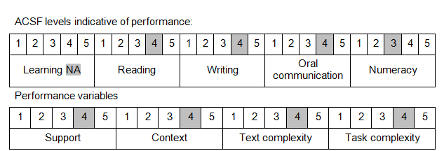

Further information on ACSF and the foundation skills underpinning this unit can be found in the Foundation Skills Guide on the GSA website.

Unit Mapping Information
This unit supersedes and is equivalent to PSPCRT412B Record court proceedings.

Links
Companion Volume implementation guides are found in VETNet - https://vetnet.gov.au/Pages/TrainingDocs.aspx?q=bebbece7-ff48-4d2c-8876-405679019623
Companion Volume implementation guides are found in VETNet - https://vetnet.gov.au/Pages/TrainingDocs.aspx?q=bebbece7-ff48-4d2c-8876-405679019623
Companion Volume implementation guides are found in VETNet - https://vetnet.gov.au/Pages/TrainingDocs.aspx?q=bebbece7-ff48-4d2c-8876-405679019623
Companion Volume implementation guides are found in VETNet - https://vetnet.gov.au/Pages/TrainingDocs.aspx?q=bebbece7-ff48-4d2c-8876-405679019623

