PSPCRT009 Provide court registry and information services
Release: 1

PSPCRT009 Provide court registry and information services

Modification History
Release | Comments
1 | This unit was released in PSP Public Sector Training Package release 1.0 and meets the Standards for Training Packages.  This unit supersedes and is equivalent to PSPCRT408B Provide court registry and information services.  - Unit code updated  - Content and formatting updated to comply with new standards  - All PC transitioned from passive to active voice  - PC 3.3 removed

Application
This unit describes the skills required to provide an effective registry and information service to court clients according to the court’s business plan. It includes advising on court practice and procedures, processing incoming registry work, and handling documents and exhibits lodged.
This unit applies to those working within the court system operating under procedures set by the court.
The skills and knowledge described in this unit must be applied within the legislative, regulatory and policy environment in which they are carried out. Organisational policies and procedures must be consulted and adhered to, particularly those set by the court.
Those undertaking this unit would generally work independently with occasional supervisory responsibilities. They would perform complex tasks in a range of familiar and unfamiliar contexts.
No licensing, legislative or certification requirements apply to unit at the time of publication.

Competency Field
Courts

Elements and Performance Criteria
ELEMENTS | PERFORMANCE CRITERIA
Elements describe the essential outcomes | Performance criteria describe the performance needed to demonstrate achievement of the element. Where bold italicised text is used, further information is detailed in the range of conditions section.
1. Communicate court practice and procedures | 1.1 Provide information, options and advice on legislation requirements and organisational policy and procedures.  1.2 Respond to questions related to client diversity and needs according to client service practice and standards.  1.3 Offer solutions to problems raised by clients and provide options and/or referrals in accordance with delegated authority.  1.4 Refer complex operational queries and obtain assistance when necessary.  1.5 Optimise information services through use of technical resources and digital information systems.
2. Process incoming registry work | 2.1 Process incoming applications and other materials.  2.2 Transfer files using appropriate technical resources in accordance with listings and registry requirements.  2.3 Process and receipt fees.
3. Handle lodged documents | 3.1 Receive and record documents.  3.2 Lodge documents and enter information into the file management system within set timeframes.

Foundation Skills
The foundation skills demands of this unit have been mapped for alignment with the Australian Core Skills Framework (ACSF). The following tables outline the performance levels indicated for successful attainment of the unit.

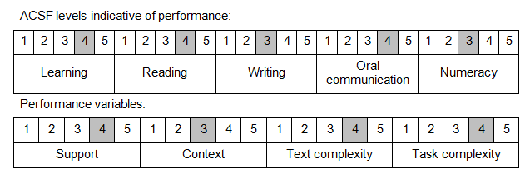

Further information on ACSF and the foundation skills underpinning this unit can be found in the Foundation Skills Guide on the GSA website.

Unit Mapping Information
This unit supersedes and is equivalent to PSPCRT408B Provide court registry and information services.

Links
Companion Volume implementation guides are found in VETNet - https://vetnet.gov.au/Pages/TrainingDocs.aspx?q=bebbece7-ff48-4d2c-8876-405679019623
Companion Volume implementation guides are found in VETNet - https://vetnet.gov.au/Pages/TrainingDocs.aspx?q=bebbece7-ff48-4d2c-8876-405679019623
Companion Volume implementation guides are found in VETNet - https://vetnet.gov.au/Pages/TrainingDocs.aspx?q=bebbece7-ff48-4d2c-8876-405679019623
Companion Volume implementation guides are found in VETNet - https://vetnet.gov.au/Pages/TrainingDocs.aspx?q=bebbece7-ff48-4d2c-8876-405679019623

