PSPCRT008 Undertake court listings
Release: 1

PSPCRT008 Undertake court listings

Modification History
Release | Comments
1 | This unit was released in PSP Public Sector Training Package release 1.0 and meets the Standards for Training Packages.  This unit supersedes and is equivalent to PSPCRT407B Undertake court listings.  - Unit code updated  - Content and formatting updated to comply with new standards  - All PC transitioned from passive to active voice  - PC 1.1 and 1.2, PC 1.3 and 1.4, PC 2.2 and 2.3 merged  - PC 4.1 removed

Application
This unit describes the skills required to undertake court listings in a range of matters for courts. It includes preparing court files, maintaining listing systems, assisting in the allocation of courtrooms and judicial officers, preparing court lists and advising on listings.
This unit applies to those working within the court system operating under procedures set by the court.
The skills and knowledge described in this unit must be applied within the legislative, regulatory and policy environment in which they are carried out. Organisational policies and procedures must be consulted and adhered to, particularly those set by the court.
Those undertaking this unit would generally work independently with occasional supervisory responsibilities. They would perform complex tasks in a range of familiar and unfamiliar contexts.
No licensing, legislative or certification requirements apply to unit at the time of publication.

Competency Field
Courts

Elements and Performance Criteria
ELEMENTS | PERFORMANCE CRITERIA
Elements describe the essential outcomes | Performance criteria describe the performance needed to demonstrate achievement of the element. Where bold italicised text is used, further information is detailed in the range of conditions section.
1. Prepare court files | 1.1 Locate and check files listed to ensure relevant documents are on file and any missing documents followed up.  1.2 Prepare documentation and advise when files are ready for collection.
2. Maintain listing systems | 2.1 Set up listing system according to the number of available presiding officials as per roster.  2.2 Establish and distribute lists for hearings.
3. Assist allocation of courtrooms and judicial officers | 3.1 Access list of pending cases from records and obtain information on priorities.  3.2 Allocate cases to judicial officers.  3.3 Locate and sort files.
4. Prepare court lists | 4.1 Gather other information on matters and take appropriate action.  4.2 Record data relating to the allocation of court and judicial officers.  4.3 Prepare and print completed lists of all matters and distribute.
5. Provide information and options on listings | 5.1 Prepare documentation and send to parties.  5.2 Book interpreters as required.  5.3 Make contact with all parties and necessary staff for urgent matters.  5.4 Complete records and forward.

Foundation Skills
The foundation skills demands of this unit have been mapped for alignment with the Australian Core Skills Framework (ACSF). The following tables outline the performance levels indicated for successful attainment of the unit.

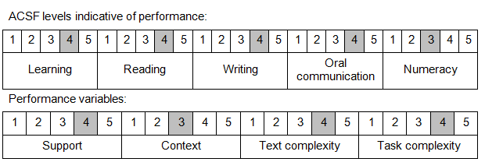

Further information on ACSF and the foundation skills underpinning this unit can be found in the Foundation Skills Guide on the GSA website.

Unit Mapping Information
This unit supersedes and is equivalent to PSPCRT407B Undertake court listings.

Links
Companion Volume implementation guides are found in VETNet - https://vetnet.gov.au/Pages/TrainingDocs.aspx?q=bebbece7-ff48-4d2c-8876-405679019623
Companion Volume implementation guides are found in VETNet - https://vetnet.gov.au/Pages/TrainingDocs.aspx?q=bebbece7-ff48-4d2c-8876-405679019623
Companion Volume implementation guides are found in VETNet - https://vetnet.gov.au/Pages/TrainingDocs.aspx?q=bebbece7-ff48-4d2c-8876-405679019623
Companion Volume implementation guides are found in VETNet - https://vetnet.gov.au/Pages/TrainingDocs.aspx?q=bebbece7-ff48-4d2c-8876-405679019623

