PSPCRT006 Handle monies received in satisfaction of warrants and orders
Release: 1

PSPCRT006 Handle monies received in satisfaction of warrants and orders

Modification History
Release | Comments
1 | This unit was released in PSP Public Sector Training Package release 1.0 and meets the Standards for Training Packages.  This unit supersedes and is equivalent to PSPCRT405C Handle monies received in satisfaction of warrants and orders.  - Unit code updated  - Content and formatting updated to comply with new standards  - All PC transitioned from passive to active voice

Application
This unit describes the skills required to securely collect and bank monies received in satisfaction of warrants and orders. It includes dealing with difficult collection situations and applying knowledge of the policies, procedures and legislation relating to handling civil monies.
This unit applies to those working within the court system operating under procedures set by the court.
The skills and knowledge described in this unit must be applied within the legislative, regulatory and policy environment in which they are carried out. Organisational policies and procedures must be consulted and adhered to, particularly those set by the court.
Those undertaking this unit would generally work independently with occasional supervisory responsibilities. They would perform complex tasks in a range of familiar and unfamiliar contexts.
No licensing, legislative or certification requirements apply to unit at the time of publication.

Competency Field
Courts

Elements and Performance Criteria
ELEMENTS | PERFORMANCE CRITERIA
Elements describe the essential outcomes | Performance criteria describe the performance needed to demonstrate achievement of the element. Where bold italicised text is used, further information is detailed in the range of conditions section.
1. Receive monies | 1.1 Obtain or confirm authorisations for the collection of monies in satisfaction of an order or warrant.  1.2 Undertake risk assessment and determine strategies to remove, control or minimise identified risks.  1.3 Respond to queries or requests for information using established customer service techniques.  1.4 Collect and receipt monies and implement contingencies to protect the safety of self and others as required.  1.5 Maintain security of monies and receipt books.
2. Deposit monies received | 2.1 Secure or bank monies received according to designated timelines and legislative requirements for the type of process served and the jurisdiction.  2.2 Maintain receipts and banking data, process payments and complete records.

Foundation Skills
The foundation skills demands of this unit have been mapped for alignment with the Australian Core Skills Framework (ACSF). The following tables outline the performance levels indicated for successful attainment of the unit.

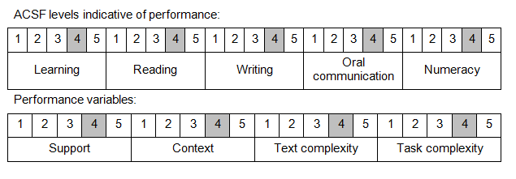

Further information on ACSF and the foundation skills underpinning this unit can be found in the Foundation Skills Guide on the GSA website.

Range of Conditions
The foundation skills demands of this unit have been mapped for alignment with the Australian Core Skills Framework (ACSF). The following tables outline the performance levels indicated for successful attainment of the unit.

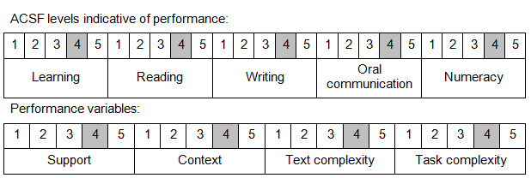

Further information on ACSF and the foundation skills underpinning this unit can be found in the Foundation Skills Guide on the GSA website.

Unit Mapping Information
This unit supersedes and is equivalent to PSPCRT405C Handle monies received in satisfaction of warrants and orders.

Links
Companion Volume implementation guides are found in VETNet - https://vetnet.gov.au/Pages/TrainingDocs.aspx?q=bebbece7-ff48-4d2c-8876-405679019623
Companion Volume implementation guides are found in VETNet - https://vetnet.gov.au/Pages/TrainingDocs.aspx?q=bebbece7-ff48-4d2c-8876-405679019623
Companion Volume implementation guides are found in VETNet - https://vetnet.gov.au/Pages/TrainingDocs.aspx?q=bebbece7-ff48-4d2c-8876-405679019623
Companion Volume implementation guides are found in VETNet - https://vetnet.gov.au/Pages/TrainingDocs.aspx?q=bebbece7-ff48-4d2c-8876-405679019623

