PSPCRT006 Handle monies received in satisfaction of warrants and orders
Release: 1

PSPCRT006 Handle monies received in satisfaction of warrants and orders

Modification History
Release | Comments
1 | This unit was released in PSP Public Sector Training Package release 1.0 and meets the Standards for Training Packages.  This unit supersedes and is equivalent to PSPCRT405C Handle monies received in satisfaction of warrants and orders.  - Unit code updated  - Content and formatting updated to comply with new standards  - All PC transitioned from passive to active voice

Application
This unit describes the skills required to securely collect and bank monies received in satisfaction of warrants and orders. It includes dealing with difficult collection situations and applying knowledge of the policies, procedures and legislation relating to handling civil monies.
This unit applies to those working within the court system operating under procedures set by the court.
The skills and knowledge described in this unit must be applied within the legislative, regulatory and policy environment in which they are carried out. Organisational policies and procedures must be consulted and adhered to, particularly those set by the court.
Those undertaking this unit would generally work independently with occasional supervisory responsibilities. They would perform complex tasks in a range of familiar and unfamiliar contexts.
No licensing, legislative or certification requirements apply to unit at the time of publication.

Competency Field
Courts

Elements and Performance Criteria
ELEMENTS | PERFORMANCE CRITERIA
Elements describe the essential outcomes | Performance criteria describe the performance needed to demonstrate achievement of the element. Where bold italicised text is used, further information is detailed in the range of conditions section.
1. Receive monies | 1.1 Obtain or confirm authorisations for the collection of monies in satisfaction of an order or warrant.  1.2 Undertake risk assessment and determine strategies to remove, control or minimise identified risks.  1.3 Respond to queries or requests for information using established customer service techniques.  1.4 Collect and receipt monies and implement contingencies to protect the safety of self and others as required.  1.5 Maintain security of monies and receipt books.
2. Deposit monies received | 2.1 Secure or bank monies received according to designated timelines and legislative requirements for the type of process served and the jurisdiction.  2.2 Maintain receipts and banking data, process payments and complete records.

Foundation Skills
The foundation skills demands of this unit have been mapped for alignment with the Australian Core Skills Framework (ACSF). The following tables outline the performance levels indicated for successful attainment of the unit.

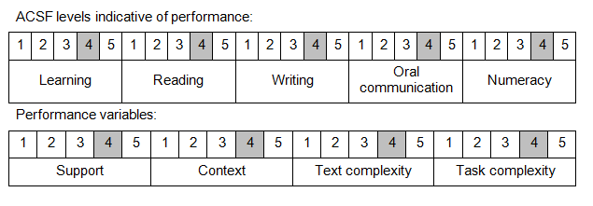

Further information on ACSF and the foundation skills underpinning this unit can be found in the Foundation Skills Guide on the GSA website.

Range of Conditions
The foundation skills demands of this unit have been mapped for alignment with the Australian Core Skills Framework (ACSF). The following tables outline the performance levels indicated for successful attainment of the unit.

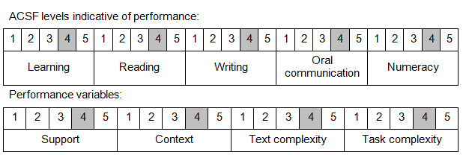

Further information on ACSF and the foundation skills underpinning this unit can be found in the Foundation Skills Guide on the GSA website.

Unit Mapping Information
This unit supersedes and is equivalent to PSPCRT405C Handle monies received in satisfaction of warrants and orders.

Links
Companion Volume implementation guides are found in VETNet - https://vetnet.gov.au/Pages/TrainingDocs.aspx?q=bebbece7-ff48-4d2c-8876-405679019623
Companion Volume implementation guides are found in VETNet - https://vetnet.gov.au/Pages/TrainingDocs.aspx?q=bebbece7-ff48-4d2c-8876-405679019623
Companion Volume implementation guides are found in VETNet - https://vetnet.gov.au/Pages/TrainingDocs.aspx?q=bebbece7-ff48-4d2c-8876-405679019623
Companion Volume implementation guides are found in VETNet - https://vetnet.gov.au/Pages/TrainingDocs.aspx?q=bebbece7-ff48-4d2c-8876-405679019623

Assessment Requirements for PSPCRT006 Handle monies received in satisfaction of warrants and orders

Modification History
Release | Comments
1 | These Assessment Requirements were released in PSP Public Sector Training Package release 1.0 and meet the Standards for Training Packages.  - Assessment Requirements created drawing upon specified assessment information from superseded unit

Performance Evidence
Evidence required to demonstrate competence must satisfy all of the requirements of the elements and performance criteria. If not otherwise specified the candidate must demonstrate evidence of performance of the following on at least one occasion.
- eliciting required payment from clients and clarifying processes
- dealing with difficult customer service situations
- receipting payments
- completing and maintaining financial records
- operating technology for credit card transactions or electronic funds transfer
- problem-solving and responding to contingencies
- applying legislation, regulations and policies relating to money handling
- working in the field collecting monies to satisfy warrants and orders

Knowledge Evidence
Evidence required to demonstrate competence must satisfy all of the requirements of the elements and performance criteria. If not otherwise specified the depth of knowledge demonstrated must be appropriate to the job context of the candidate.
- legislation, regulations and organisational policy and procedures relating to control of monies received in satisfaction of warrants and orders
- operational safety procedures
- financial guidelines relating to the collection, receipting, security and banking of monies in the public sector
- duty of care requirements relating to handling monies received in satisfaction of warrants and orders
- software relating to financial administration

Assessment Conditions
Assessment of this unit requires evidence gathered over time in a workplace environment or one that closely resembles normal work practice and replicates the diverse conditions likely to be encountered when handling monies received in satisfaction of warrants and orders.
Assessors must satisfy the NVR/AQTF mandatory competency requirements for assessors.

Links
Companion Volume implementation guides are found in VETNet - https://vetnet.gov.au/Pages/TrainingDocs.aspx?q=bebbece7-ff48-4d2c-8876-405679019623
Companion Volume implementation guides are found in VETNet - https://vetnet.gov.au/Pages/TrainingDocs.aspx?q=bebbece7-ff48-4d2c-8876-405679019623
Companion Volume implementation guides are found in VETNet - https://vetnet.gov.au/Pages/TrainingDocs.aspx?q=bebbece7-ff48-4d2c-8876-405679019623

