PSPCRT004 Handle exhibits and documents tendered
Release: 1

PSPCRT004 Handle exhibits and documents tendered

Modification History
Release | Comments
1 | This unit was released in PSP Public Sector Training Package release 1.0 and meets the Standards for Training Packages.  This unit supersedes and is equivalent to PSPCRT403C Handle exhibits and documents tendered  - Unit code updated  - Content and formatting updated to comply with new standards  - All PC transitioned from passive to active voice  - PC 1.1 and 1.2 merged

Application
This unit describes the skills required to deal with court exhibits and documents tendered to the court. It includes the handling and security of exhibits and documents and completing the necessary documentation.
This unit applies to those working within the court system operating under procedures set by the court.
The skills and knowledge described in this unit must be applied within the legislative, regulatory and policy environment in which they are carried out. Organisational policies and procedures must be consulted and adhered to, particularly those set by the court.
Those undertaking this unit would generally work independently, with occasional supervisory responsibilities. They would perform routine tasks in a range of familiar and unfamiliar contexts.
No licensing, legislative or certification requirements apply to unit at the time of publication.

Competency Field
Courts

Elements and Performance Criteria
ELEMENTS | PERFORMANCE CRITERIA
Elements describe the essential outcomes | Performance criteria describe the performance needed to demonstrate achievement of the element. Where bold italicised text is used, further information is detailed in the range of conditions section.
1. Follow procedures to handle exhibits and documents | 1.1 Receive, record and secure exhibits and documents.  1.2 Pass exhibits and documents for examination as directed by the court.  1.3 Handle hazardous exhibits and documents using safety procedures and personal protective equipment.  1.4 Complete court documentation relating to exhibits and documents.
2. Process exhibits and documents | 2.1 Check court registry for exhibits and documents tendered by the parties and complete administrative requirements.  2.2 Store and secure exhibits and documents.  2.3 Deliver exhibits and documents to court when required.  2.4 Implement administrative arrangements for tendered documents in accordance with the outcomes of the court process.

Foundation Skills
The foundation skills demands of this unit have been mapped for alignment with the Australian Core Skills Framework (ACSF). The following tables outline the performance levels indicated for successful attainment of the unit.

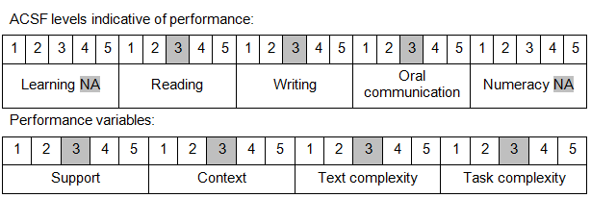

Further information on ACSF and the foundation skills underpinning this unit can be found in the Foundation Skills Guide on the GSA website.

Unit Mapping Information
This unit supersedes and is equivalent to PSPCRT403C Handle exhibits and documents tendered

Links
Companion Volume implementation guides are found in VETNet - https://vetnet.gov.au/Pages/TrainingDocs.aspx?q=bebbece7-ff48-4d2c-8876-405679019623
Companion Volume implementation guides are found in VETNet - https://vetnet.gov.au/Pages/TrainingDocs.aspx?q=bebbece7-ff48-4d2c-8876-405679019623
Companion Volume implementation guides are found in VETNet - https://vetnet.gov.au/Pages/TrainingDocs.aspx?q=bebbece7-ff48-4d2c-8876-405679019623
Companion Volume implementation guides are found in VETNet - https://vetnet.gov.au/Pages/TrainingDocs.aspx?q=bebbece7-ff48-4d2c-8876-405679019623

