PSPCRT003 Manage witnesses
Release: 1

PSPCRT003 Manage witnesses

Modification History
Release | Comments
1 | This unit was released in PSP Public Sector Training Package release 1.0 and meets the Standards for Training Packages.  This unit supersedes and is equivalent to PSPCRT402C Manage witnesses.  - Unit code updated  - Content and formatting updated to comply with the new standards  - All PC transitioned from passive to active voice  - PC 1.2 and 1.3 revised

Application
This unit describes the skills required to manage witnesses attending court to give evidence face-to-face or via audio-visual link facilities. It includes facilitating witnesses’ court appearances and maintaining the integrity of court proceedings in a remote witness room.
This unit applies to those working within the court system operating under procedures set by the court.
The skills and knowledge described in this unit must be applied within the legislative, regulatory and policy environment in which they are carried out. Organisational policies and procedures must be consulted and adhered to, particularly those relating to WHS and those set by the court.
Those undertaking this unit would generally work independently with occasional supervisory responsibilities. They would perform complex tasks in a range of familiar and unfamiliar contexts.
No licensing, legislative or certification requirements apply to unit at the time of publication.

Competency Field
Courts

Elements and Performance Criteria
ELEMENTS | PERFORMANCE CRITERIA
Elements describe the essential outcomes | Performance criteria describe the performance needed to demonstrate achievement of the element. Where bold italicised text is used, further information is detailed in the range of conditions section.
1. Facilitate court appearances of witnesses | 1.1 Apply requirements regarding presence of witnesses according to for the type of proceeding.  1.2 Identify witnesses and provide details to the court.  1.3 Record witness details and report non-appearances.  1.4 Call witnesses, escort them to the witness box and swear in, if required.  1.5 Provide appropriate screening or audio-visual link for witnesses who are apprehensive of giving evidence in front of an accused, at the direction of the presiding official.  1.6 Complete administrative duties relating to witness appearances.
2. Maintain the integrity of court proceedings in a remote witness room | 2.1 Prepare witness room and equipment.  2.2 Position witness and other authorised persons so they are visible and clearly audible to the court.  2.3 Maintain security of witnesses, witness rooms and exhibits and report any attempted security breach to the court.  2.4 Perform functions in the witness room according to set role.  2.5 Deliver witnesses at the end of the evidence and examination into the care of a responsible person and return exhibits.

Foundation Skills
The foundation skills demands of this unit have been mapped for alignment with the Australian Core Skills Framework (ACSF). The following tables outline the performance levels indicated for successful attainment of the unit.

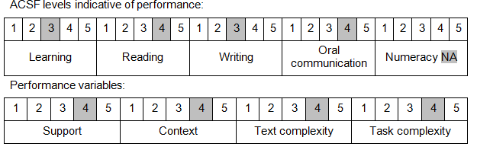

Further information on ACSF and the foundation skills underpinning this unit can be found in the Foundation Skills Guide on the GSA website.

Unit Mapping Information
This unit supersedes and is equivalent to PSPCRT402C Manage witnesses.

Links
Companion Volume implementation guides are found in VETNet - https://vetnet.gov.au/Pages/TrainingDocs.aspx?q=bebbece7-ff48-4d2c-8876-405679019623
Companion Volume implementation guides are found in VETNet - https://vetnet.gov.au/Pages/TrainingDocs.aspx?q=bebbece7-ff48-4d2c-8876-405679019623
Companion Volume implementation guides are found in VETNet - https://vetnet.gov.au/Pages/TrainingDocs.aspx?q=bebbece7-ff48-4d2c-8876-405679019623
Companion Volume implementation guides are found in VETNet - https://vetnet.gov.au/Pages/TrainingDocs.aspx?q=bebbece7-ff48-4d2c-8876-405679019623

