POLSAR005 Undertake marine search and rescue duties
Release: 1

POLSAR005 Undertake marine search and rescue duties

Modification History
Release | Comments
1 | This unit was released in POL Police Training Package release 1.0 and meets the Standards for Training Packages.

Application
This unit describes the skills required to prepare marine search and rescue (SAR) responses, determine current location and destination, plan safe routes/courses, and plan marine search and rescue operations.
This unit applies to those working as police staff involved in police marine search and rescue operations. It may be applied in the field and within office environment.
The skills and knowledge described in this unit must be applied within the legislative, regulatory and policy environment in which they are carried out. Organisational policies and procedures must be consulted and adhered to, particularly those related to work health and safety (WHS) within a marine environment.
Those undertaking this role will work within multi-agency teams and often liaise with stakeholders, while completing complex tasks in a broad range of contexts. They will have to make decisions independently while giving consideration to financial and human resource management requirements.
No licensing, legislative or certification requirements apply to unit at the time of publication.

Competency Field
Search and rescue

Elements and Performance Criteria
ELEMENTS | PERFORMANCE CRITERIA
Elements describe the essential outcomes | Performance criteria describe the performance needed to demonstrate achievement of the element. Where bold italicised text is used, further information is detailed in the range of conditions section.
1. Prepare for marine search and rescue response | 1.1 Establish rescue coordination centre to facilitate coordination of marine search and rescue operations.  1.2 Establish communications to facilitate flow of information.  1.3 Access jurisdictional information management systems to gather information in relation to target and vessel.  1.4 Assess characteristics of target and vessel to inform search and rescue response.
2. Determine current location, destination and resources | 2.1 Gather information relating to the location and details of incident to inform marine search and rescue operation.  2.2 Identify charts, electronic navigation aids and navigation equipment to source information.  2.3 Interpret information from charts for planning purposes.  2.4 Evaluate sea state, currents and tidal patterns to identify impacts on marine search and rescue operations.  2.5 Plot current location and estimated destination of vessel in distress on a chart using marine navigation techniques.
3. Determine and plan a safe route/course | 3.1 Compile operational plan, including initial search areas chart work.  3.2 Record all plots/search areas on chart using overlays and allowing for variables and prevailing conditions.  3.3 Estimate rescue asset’s speeds, search time, investigation time and endurance within prevailing conditions to provide an estimated search time.  3.4 Identify potential obstacles and hazards to determine safe route/course.
4. Perform marine search and rescue response | 4.1 Determine datum of target using wind and currents.  4.2 Utilise marine search strategies to inform marine search and rescue operations.  4.3 Select marine search patterns in accordance with prevailing conditions.  4.4 Identify specialist marine resources to facilitate marine search and rescue operations.  4.5 Allocate taskings for resources to facilitate marine search and rescue operations.  4.6 Modify marine search strategies using on scene intelligence.

Foundation Skills
The foundation skills demands of this unit have been mapped for alignment with the Australian Core Skills Framework (ACSF). The following tables outline the performance levels indicated for successful attainment of the unit.

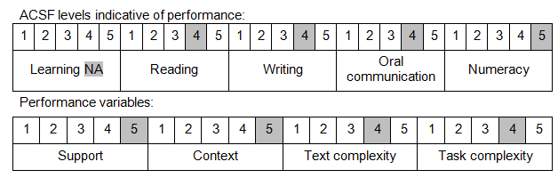

Further information on ACSF and the foundation skills underpinning this unit can be found in the Foundation Skills Guide on the GSA website.

Unit Mapping Information
No equivalent unit.

Links
Companion Volume implementation guides are found in VETNet - https://vetnet.gov.au/Pages/TrainingDocs.aspx?q=98c3984e-2cf1-48a8-8ed1-85e4b92e7351
Companion Volume implementation guides are found in VETNet - https://vetnet.gov.au/Pages/TrainingDocs.aspx?q=98c3984e-2cf1-48a8-8ed1-85e4b92e7351
Companion Volume implementation guides are found in VETNet - https://vetnet.gov.au/Pages/TrainingDocs.aspx?q=98c3984e-2cf1-48a8-8ed1-85e4b92e7351

