POLSAR002 Manages resources for police search and rescue operations
Release: 1

POLSAR002 Manages resources for police search and rescue operations

Modification History
Release | Comments
1 | This unit was released in POL Police Training Package release 1.0 and meets the Standards for Training Packages.

Application
This unit describes the skills required to liaise with stakeholders to acquire and manage resources required for search and rescue (SAR) operations.
This unit applies to police staff involved in police search and rescue operations.
The skills and knowledge described in this unit must be applied within the legislative, regulatory and policy environment in which they are carried out. Organisational policies and procedures must be consulted and adhered to, particularly those related to resource acquisitions and financial delegations.
Those undertaking this role may work autonomously and supervising teams while remaining responsible for reporting to senior staff. They would demonstrate adaptability across a broad range of contexts while performing complex tasks.
No licensing, legislative or certification requirements apply to unit at the time of publication.

Competency Field
Search and rescue

Elements and Performance Criteria
ELEMENTS | PERFORMANCE CRITERIA
Elements describe the essential outcomes | Performance criteria describe the performance needed to demonstrate achievement of the element. Where bold italicised text is used, further information is detailed in the range of conditions section.
1. Initiate coordination | 1.1 Establish management function within a SAR coordination centre.  1.2 Establish coordination structure appropriate to the nature and complexity of SAR operation.  1.3 Integrate coordination structure with the control and command activities to meet the objectives of the SAR plan.  1.4 Modify coordination structure in response to changes within the SAR operation.  1.5 Establish communication lines with stakeholders to facilitate flow of information.
2. Manage resource requirements | 2.1 Identify resources to respond to SAR incident.  2.2 Acquire resources to meet the requirements of SAR plan including personnel support activities.  2.3 Assess financial requirements and associated authorisations to facilitate resource management.  2.4 Supply resources to meet operational requirements within negotiated timeframes.  2.5 Monitor allocation of resources to ensure operational effectiveness and to identify additional requirements.  2.6 Assess resource requirements for protracted operations.  2.7 Liaise with stakeholders to facilitate resupply and negotiation for ongoing resource requirements.
3. Conclude coordination activities | 3.1 Conduct an audit to ensure resources were acquired and supplied in a cost-effective and efficient manner.  3.2 Return resources released from SAR operation to providers.  3.3 Manage financial arrangements arising from SAR operations.
4. Review coordination | 4.1 Evaluate coordination effectiveness through debriefings and peer reviews.  4.2 Review actions taken, procedures and policies to identify opportunities for improvement.  4.3 Develop recommendations for continuous improvement purposes.  4.4 Develop reports for accountability purposes.

Foundation Skills
The foundation skills demands of this unit have been mapped for alignment with the Australian Core Skills Framework (ACSF). The following tables outline the performance levels indicated for successful attainment of the unit.

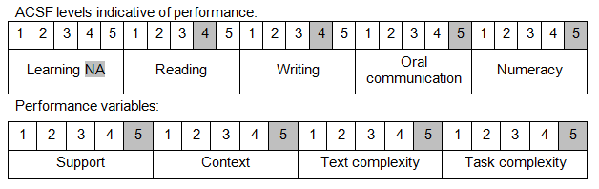

Further information on ACSF and the foundation skills underpinning this unit can be found in the Foundation Skills Guide on the GSA website.

Unit Mapping Information
No equivalent unit.

Links
Companion Volume implementation guides are found in VETNet - https://vetnet.gov.au/Pages/TrainingDocs.aspx?q=98c3984e-2cf1-48a8-8ed1-85e4b92e7351
Companion Volume implementation guides are found in VETNet - https://vetnet.gov.au/Pages/TrainingDocs.aspx?q=98c3984e-2cf1-48a8-8ed1-85e4b92e7351
Companion Volume implementation guides are found in VETNet - https://vetnet.gov.au/Pages/TrainingDocs.aspx?q=98c3984e-2cf1-48a8-8ed1-85e4b92e7351

