POLSAR001 Manage and evaluate search and rescue exercises
Release: 1

POLSAR001 Manage and evaluate search and rescue exercises

Modification History
Release | Comments
1 | This unit was released in POL Police Training Package release 1.0 and meets the Standards for Training Packages.

Application
This unit describes the skills required to design, plan, manage and evaluate search and rescue (SAR) exercises, including communication and consultation with stakeholders.
This unit applies to police staff involved in police search and rescue operations. This unit applies to search and rescue exercises at a local level.
The skills and knowledge described in this unit must be applied within the legislative, regulatory and policy environment in which they are carried out. Organisational policies and procedures must be consulted and adhered to, particularly those related to resource acquisitions and exercise authorisations.
Those undertaking this role would work autonomously and supervise teams while reporting to senior staff. They would demonstrate adaptability while performing sophisticated tasks across a broad range of contexts.
No licensing, legislative or certification requirements apply to unit at the time of publication.

Competency Field
Search and rescue

Elements and Performance Criteria
ELEMENTS | PERFORMANCE CRITERIA
Elements describe the essential outcomes | Performance criteria describe the performance needed to demonstrate achievement of the element. Where bold italicised text is used, further information is detailed in the range of conditions section.
1. Design search and rescue exercise | 1.1 Determine search and rescue exercise purpose in consultation with stakeholders and based on operational outcomes, results of training needs analysis, previous exercises and evaluation reports.  1.2 Develop exercise plan with identified components of the exercise program in consultation with stakeholders.  1.3 Identify agencies/organisations required to facilitate search and rescue exercise.  1.4 Evaluate feasibility of exercise program in accordance with resource availability.  1.5 Select exercise style and activities consistent with exercise objectives.  1.6 Conduct risk assessment to identify risk and safety factors.
2. Plan resource allocation | 2.1 Identify resources to support the exercise.  2.2 Obtain appropriate authorisation(s) to use resources.  2.3 Negotiate availability and time frames for use of resources with appropriate authorities.
3. Manage police SAR exercise activities | 3.1 Communicate with activity personnel to facilitate flow of information throughout the exercise.  3.2 Prepare exercise site in accordance with the exercise plan.  3.3 Deliver briefings to stakeholders reflecting exercise objectives and activities.  3.4 Ensure confirmation and management of logistic requirements required to conduct exercise activities.  3.5 Manage risk throughout the conduct of the police SAR exercise.
4. Evaluate outcomes against SAR exercise objectives | 4.1 Conduct post-exercise debriefings to gather feedback.  4.2 Collate exercise feedback for recording purposes.  4.3 Analyse exercise feedback to identify issues.  4.4 Produce an exercise report, including recommendations.

Foundation Skills
The foundation skills demands of this unit have been mapped for alignment with the Australian Core Skills Framework (ACSF). The following tables outline the performance levels indicated for successful attainment of the unit.

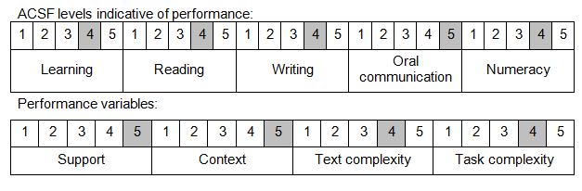

Further information on ACSF and the foundation skills underpinning this unit can be found in the Foundation Skills Guide on the GSA website.

Unit Mapping Information
No equivalent unit.

Links
Companion Volume implementation guides are found in VETNet - https://vetnet.gov.au/Pages/TrainingDocs.aspx?q=98c3984e-2cf1-48a8-8ed1-85e4b92e7351
Companion Volume implementation guides are found in VETNet - https://vetnet.gov.au/Pages/TrainingDocs.aspx?q=98c3984e-2cf1-48a8-8ed1-85e4b92e7351
Companion Volume implementation guides are found in VETNet - https://vetnet.gov.au/Pages/TrainingDocs.aspx?q=98c3984e-2cf1-48a8-8ed1-85e4b92e7351

