POLPRO004 Utilise the Rules of Evidence
Release: 1

POLPRO004 Utilise the Rules of Evidence

Modification History
Release | Comments
1 | This unit was released in POL Police Training Package release 1.0 and meets the Standards for Training Packages.  This unit supersedes and is equivalent to PUAPOLPR001A Utilise the Rules of Evidence.  - Content and formatting updated to comply with new standards  - Unit recoded POL  - Elements 1 and 2 merged  - Elements 3 and 4 merged  - PC. 2.1 and 2.4 merged  - PC 2.3 and 4.1 removed

Application
This unit describes the skills required to categorise and analyse evidence and adduce evidence. This includes performing prosecution duties in a professional, ethical and accountable manner that ensures public confidence in the police.
This unit applies to police prosecutors applying Rules of Evidence when reviewing briefs and cases.
The skills and knowledge described in this unit must be applied within the legislative, regulatory and policy environment in which they are carried out. Organisational policies and procedures must be consulted and adhered to, particularly those related to laws of evidence.
Those undertaking this unit would generally work autonomously within a court/justice system environment but may be required to work under supervision at times. They will be required to while perform sophisticated tasks and demonstrate adaptability across a broad range of contexts.
No licensing, legislative or certification requirements apply to unit at the time of publication.

Competency Field
Prosecution

Elements and Performance Criteria
ELEMENTS | PERFORMANCE CRITERIA
Elements describe the essential outcomes | Performance criteria describe the performance needed to demonstrate achievement of the element. Where bold italicised text is used, further information is detailed in the range of conditions section.
1. Analyse evidence | 1.1 Identify elements of the offence.  1.2 Identify evidence that supports elements of offence.  1.3 Categorise supporting evidence in relation to each element of the offence/s.  1.4 Identify applicable evidentiary law to categorised evidence.  1.5 Examine evidence to determine relevance and admissibility.
2. Adduce evidence | 2.1 Determine methods for adducing evidence.  2.2 Apply determined methods to adduce evidence.  2.3 Re-evaluate inadmissible evidence to determine alternative methods for adducing evidence.  2.4 Conduct legal research to support alternative methods for adducing evidence.  2.5 Deliver submissions to elicit decisions from the court.

Foundation Skills
The foundation skills demands of this unit have been mapped for alignment with the Australian Core Skills Framework (ACSF). The following tables outline the performance levels indicated for successful attainment of the unit.

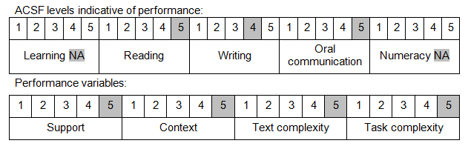

Further information on ACSF and the foundation skills underpinning this unit can be found in the Foundation Skills Guide on the GSA website.

Unit Mapping Information
This unit supersedes and is equivalent to PUAPOLPR001A Utilise the Rules of Evidence.

Links
Companion Volume implementation guides are found in VETNet - https://vetnet.gov.au/Pages/TrainingDocs.aspx?q=98c3984e-2cf1-48a8-8ed1-85e4b92e7351
Companion Volume implementation guides are found in VETNet - https://vetnet.gov.au/Pages/TrainingDocs.aspx?q=98c3984e-2cf1-48a8-8ed1-85e4b92e7351
Companion Volume implementation guides are found in VETNet - https://vetnet.gov.au/Pages/TrainingDocs.aspx?q=98c3984e-2cf1-48a8-8ed1-85e4b92e7351

