POLPRO003 Conduct legal research
Release: 1

POLPRO003 Conduct legal research

Modification History
Release | Comments
1 | This unit was released in POL Police Training Package release 1.0 and meets the Standards for Training Packages.  This unit supersedes and is equivalent to PUAPOLPR002A Conduct legal research.  - Content and formatting updated to comply with new standards  - Unit recoded POL  - Element 2 and 3 merged and all PC reordered  - New PC added to Element 4  - PC 1.1, 1.2 and 1.3 merged

Application
This unit describes the skills required to define legal issues, undertake research, identify legal principles and communicate results. This includes performing prosecution duties in a professional, ethical and accountable manner that ensures public confidence in the police.
This unit applies to police prosecutors undertaking legal research as part of their preparation for delivering a case.
The skills and knowledge described in this unit must be applied within the legislative, regulatory and policy environment in which they are carried out. Organisational policies and procedures must be consulted and adhered to, particularly those related to information management and security and safe use of information technology.
Those undertaking this unit would generally work autonomously within a court/justice system environment but may be required to work under supervision at times. They will be required to conduct sophisticated research tasks and demonstrate adaptability across a broad range of contexts.
No licensing, legislative or certification requirements apply to unit at the time of publication.

Competency Field
Prosecution

Elements and Performance Criteria
ELEMENTS | PERFORMANCE CRITERIA
Elements describe the essential outcomes | Performance criteria describe the performance needed to demonstrate achievement of the element. Where bold italicised text is used, further information is detailed in the range of conditions section.
1. Define legal issues | 1.1 Analyse information to determine factual situation.  1.2 Evaluate information to identify legal issues requiring research.
2. Undertake research | 2.1 Define search parameters to narrow the scope of enquiry.  2.2 Identify sources of law to address the identified legal issue.  2.3 Develop research strategies based on subject, case, legislation, instrument or other relevant search terms.  2.4 Implement research strategies to locate sources of law.
3. Identify legal principles | 3.1 Interpret sources of law to facilitate critical analysis.  3.2 Analyse sources of law critically to distil the legal precedent and determine application to the legal issue.  3.3 Formulate response to the legal issue based on research.  3.4 Communicate responses to inform stakeholders.

Foundation Skills
The foundation skills demands of this unit have been mapped for alignment with the Australian Core Skills Framework (ACSF). The following tables outline the performance levels indicated for successful attainment of the unit.

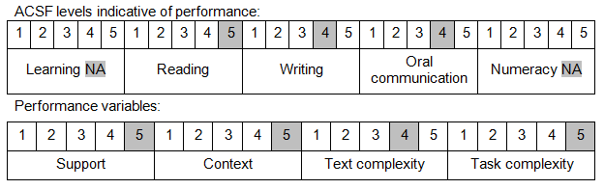

Further information on ACSF and the foundation skills underpinning this unit can be found in the Foundation Skills Guide on the GSA website.

Unit Mapping Information
This unit supersedes and is equivalent to PUAPOLPRO002A Conduct legal research.

Links
Companion Volume implementation guides are found in VETNet - https://vetnet.gov.au/Pages/TrainingDocs.aspx?q=98c3984e-2cf1-48a8-8ed1-85e4b92e7351
Companion Volume implementation guides are found in VETNet - https://vetnet.gov.au/Pages/TrainingDocs.aspx?q=98c3984e-2cf1-48a8-8ed1-85e4b92e7351
Companion Volume implementation guides are found in VETNet - https://vetnet.gov.au/Pages/TrainingDocs.aspx?q=98c3984e-2cf1-48a8-8ed1-85e4b92e7351

