POLPRO002 Conduct pre-hearing mentions
Release: 1

POLPRO002 Conduct pre-hearing mentions

Modification History
Release | Comments
1 | This unit was released in POL Police Training Package release 1.0 and meets the Standards for Training Packages.  This unit supersedes and is equivalent to PUAPOLPR003A Conduct a pre hearing mention.  - Content and formatting updated to comply with new standards  - Unit recoded POL  - Title updated  - All Elements and PC rewritten with operational outcome of the unit maintained

Application
This unit describes the skills required to manage a brief for pre-hearing mentions, communicate with stakeholders, present a case and complete pre-hearing mention duties. This includes performing prosecution duties in a professional, ethical and accountable manner that ensures public confidence in the police.
This unit applies to police prosecutors undertaking pre-hearing mention duties including managing briefs and presenting in court.
The skills and knowledge described in this unit must be applied within the legislative, regulatory and policy environment in which they are carried out. Organisational policies and procedures must be consulted and adhered to, particularly those related to court proceedings and prosecution guidelines.
Those undertaking this unit would generally work autonomously within a court/justice system environment but may be required to work under supervision at times. They will be required to perform complex tasks and demonstrate adaptability across a broad range of contexts.
No licensing, legislative or certification requirements apply to unit at the time of publication.

Competency Field
Prosecution

Elements and Performance Criteria
ELEMENTS | PERFORMANCE CRITERIA
Elements describe the essential outcomes | Performance criteria describe the performance needed to demonstrate achievement of the element. Where bold italicised text is used, further information is detailed in the range of conditions section.
1. Manage a brief for pre-hearing mention | 1.1 Assess brief to ensure sufficiency of evidence.  1.2 Analyse evidence to determine that it substantiates elements of offences.  1.3 Evaluate brief to determine possible defences.  1.4 Analyse brief to identify adherence to legislation and precedent.  1.5 Identify deficiencies in the brief to determine remedial actions.
2. Communicate with stakeholders | 2.1 Engage with stakeholders to resolve issues.  2.2 Negotiate with stakeholders to progress case.  2.3 Document actions undertaken on brief for recording purposes.  2.4 Provide assistance and advice to the court regarding the management of pre-hearing mentions.
3. Present a case | 3.1 Present circumstances of the case for courts consideration.  3.2 Detail issues and concessions of the case.  3.3 Evaluate the need for applications and submissions in accordance with pre-hearing mention requirements.  3.4 Assess status of unresolved issues throughout proceedings to identify further actions required.
4. Complete pre-hearing mention duties | 4.1 Analyse circumstances of the case to determine need for applications.  4.2 Submit applications to achieve desired outcome of prosecution.  4.3 Record issues and court outcomes for future reference.  4.4 Process briefs for administrative purposes.  4.5 Communicate with stakeholders to inform them of unresolved issues and outcomes.  4.6 Analyse conduct of prosecution case critically to identify areas for improvement.  4.7 Develop recommendations for continuous improvement purposes.

Foundation Skills
The foundation skills demands of this unit have been mapped for alignment with the Australian Core Skills Framework (ACSF). The following tables outline the performance levels indicated for successful attainment of the unit.

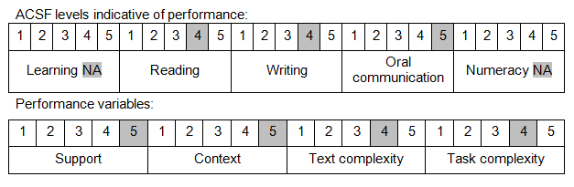

Further information on ACSF and the foundation skills underpinning this unit can be found in the Foundation Skills Guide on the GSA website.

Unit Mapping Information
This unit supersedes and is equivalent to PUAPOLPR003A Conduct a pre hearing mention.

Links
Companion Volume implementation guides are found in VETNet - https://vetnet.gov.au/Pages/TrainingDocs.aspx?q=98c3984e-2cf1-48a8-8ed1-85e4b92e7351
Companion Volume implementation guides are found in VETNet - https://vetnet.gov.au/Pages/TrainingDocs.aspx?q=98c3984e-2cf1-48a8-8ed1-85e4b92e7351
Companion Volume implementation guides are found in VETNet - https://vetnet.gov.au/Pages/TrainingDocs.aspx?q=98c3984e-2cf1-48a8-8ed1-85e4b92e7351

