POLINV007 Conduct jurisdictional review of policing practices
Release: 1

POLINV007 Conduct jurisdictional review of policing practices

Modification History
Release | Comments
1 | This unit was released in POL Police Training Package release 1.0 and meets the Standards for Training Packages.  This unit supersedes and is equivalent to PUAPOLIV007A Lead a major investigation review.  - Content and formatting updated to comply with new standards  - Unit recoded POL  - Title updated  - Element 1 reworded and all PC revised  - PC 2.1, 2.2, 2.3, 2.7, 3.1 and 3.3 revised

Application
This unit describes the skills required to perform and conduct reviews of policing practices in jurisdictions. This includes initiating, conducting and finalising reviews. Conducting reviews within a policing environment would usually involve planning and guiding the work of jurisdictional team members.
This unit applies to those working as a police officer in a designated investigation role.
The skills and knowledge described in this unit must be applied within the legislative, regulatory and policy environment in which they are carried out. Organisational policies and procedures must be consulted and adhered to, particularly those related to policing practices as specified in procedures and other documents.
Those undertaking this unit would work autonomously in the management of complex investigations, while collaborating with others in an investigation team. They would be required to possess strong decision making and problem solving skills, leadership abilities and robust communicative competence. They would be expected to display high level quality assurance abilities when reviewing policing practices, while performing sophisticated tasks in a wide range of policing contexts that can be unfamiliar.
No licensing, legislative or certification requirements apply to unit at the time of publication.

Competency Field
Investigation

Elements and Performance Criteria
ELEMENTS | PERFORMANCE CRITERIA
Elements describe the essential outcomes | Performance criteria describe the performance needed to demonstrate achievement of the element. Where bold italicised text is used, further information is detailed in the range of conditions section.
1. Initiate review process | 1.1 Negotiate with stakeholders to determine scope of review and terms of reference.  1.2 Formalise reporting arrangements and review timeframes with stakeholders.  1.3 Develop communication plan in accordance with information security principles.  1.4 Select review methods and processes in line with expectations and terms of reference.  1.5 Identify resources required to complete the review.  1.6 Document review through consultation with stakeholders.
2. Conduct reviews | 2.1 Secure resources and information required to complete review.  2.2 Assess information in accordance with the terms of reference.  2.3 Implement communication strategies in line with communications plan.  2.4 Establish information management process to document review activities and rationale for findings.  2.5 Assess review critically at regular intervals to ensure objectives are achievable within resource and legal constraints, and in line with terms of reference.  2.6 Identify urgent matters arising from the review that require immediate action.  2.7 Implement strategies to ensure confidentiality is maintained throughout the review.  2.8 Negotiate with stakeholders to adjust terms of reference.
3. Formalise review findings | 3.1 Assess and document review findings and recommendations to complete review process.  3.2 Identify further actions and recommendations generated by review findings.  3.3 Communicate review findings, recommendations and further actions to stakeholders.  3.4 Assess original information to determine archiving, retention and retrieval requirements.

Foundation Skills
The foundation skills demands of this unit have been mapped for alignment with the Australian Core Skills Framework (ACSF). The following tables outline the performance levels indicated for successful attainment of the unit.
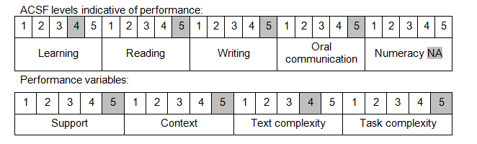
Further information on ACSF and the foundation skills underpinning this unit can be found in the Foundation Skills Guide on the GSA website.

Unit Mapping Information
This unit supersedes and is equivalent to PUAPOLIV007A Lead a major investigation review.

Links
Companion Volume implementation guides are found in VETNet - https://vetnet.gov.au/Pages/TrainingDocs.aspx?q=98c3984e-2cf1-48a8-8ed1-85e4b92e7351
Companion Volume implementation guides are found in VETNet - https://vetnet.gov.au/Pages/TrainingDocs.aspx?q=98c3984e-2cf1-48a8-8ed1-85e4b92e7351
Companion Volume implementation guides are found in VETNet - https://vetnet.gov.au/Pages/TrainingDocs.aspx?q=98c3984e-2cf1-48a8-8ed1-85e4b92e7351

