POLINV006 Lead major investigations
Release: 1

POLINV006 Lead major investigations

Modification History
Release | Comments
1 | This unit was released in POL Police Training Package release 1.0 and meets the Standards for Training Packages.  This unit supersedes and is equivalent to PUAPOLIV006A Lead major crime investigations.  - Content and formatting updated to comply with new standards  - Unit recoded POL  - Title updated  - All Element reworded  - Element 1 all PC reordered  - Element 2 all PC reordered and revised  - New Element added  - New PC added to Element 4

Application
This unit describes the skills required to manage and lead major investigations. This includes planning for, leading and concluding an investigation. It also includes guiding the work of investigation team members.
This unit applies to those working as a police officer in a designated investigation.
The skills and knowledge described in this unit must be applied within the legislative, regulatory and policy environment in which they are carried out. Organisational policies and procedures must be consulted and adhered to, particularly those related to security arrangements, investigative procedures, work health and safety (WHS), privacy and confidentiality, risk management, resource management, information management and community engagement.
Those undertaking this unit would work autonomously in the management of complex investigations, while collaborating with others in an investigation team. They would be required to possess strong decision making and problem solving skills, leadership abilities and robust communicative competence. They would perform sophisticated tasks in a wide range of policing contexts, in both familiar and unfamiliar circumstances.
No licensing, legislative or certification requirements apply to unit at the time of publication.

Competency Field
Investigation

Elements and Performance Criteria
ELEMENTS | PERFORMANCE CRITERIA
Elements describe the essential outcomes | Performance criteria describe the performance needed to demonstrate achievement of the element. Where bold italicised text is used, further information is detailed in the range of conditions section.
1. Plan a major investigation | 1.1 Determine investigation objectives to provide investigative directions.  1.2 Identify a range of information sources to inform investigative directions.  1.3 Evaluate influencing factors for planning purposes.  1.4 Evaluate resource requirements in accordance with investigative objectives.  1.5 Validate investigation plan requirements in line with command and control principles.
2. Lead a major investigation | 2.1 Analyse information to determine relevance to investigation.  2.2 Allocate resources based on investigative plan.  2.3 Oversee investigation in accordance with investigative plan.  2.4 Monitor investigation activities to develop contingency plans.  2.5 Conduct briefing and debriefing to share assessed information.  2.6 Provide advice and directions to investigation team to ensure investigation objectives are met.  2.7 Assess impacting factors to provide investigative direction.
3. Facilitate a major investigation | 3.1 Monitor expenditure and resource usage to maximise effectiveness and for reporting purposes.  3.2 Collate investigation-related material using information management systems.  3.3 Adhere to and promote security arrangements throughout investigations  3.4 Assess evidence and intelligence continually to determine impact on investigations and future investigative activities.
4. Finalise a major investigation | 4.1 Evaluate investigations to establish whether further investigative opportunities and avenues of enquiry were considered and actioned.  4.2 Record critical decisions for accountability purposes.  4.3 Finalise investigative material for referral, recording and archiving purposes.  4.4 Appraise investigations to develop recommendations and proposed future actions.

Foundation Skills
The foundation skills demands of this unit have been mapped for alignment with the Australian Core Skills Framework (ACSF). The following tables outline the performance levels indicated for successful attainment of the unit.
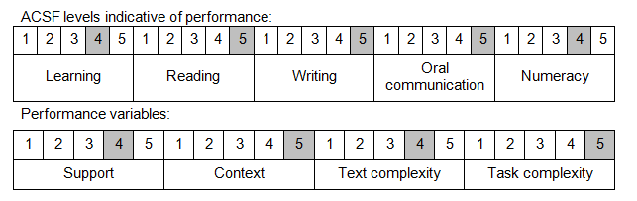
Further information on ACSF and the foundation skills underpinning this unit can be found in the Foundation Skills Guide on the GSA website.

Unit Mapping Information
This unit supersedes and is equivalent to PUAPOLIV006A Lead major crime investigations.

Links
Companion Volume implementation guides are found in VETNet - https://vetnet.gov.au/Pages/TrainingDocs.aspx?q=98c3984e-2cf1-48a8-8ed1-85e4b92e7351
Companion Volume implementation guides are found in VETNet - https://vetnet.gov.au/Pages/TrainingDocs.aspx?q=98c3984e-2cf1-48a8-8ed1-85e4b92e7351
Companion Volume implementation guides are found in VETNet - https://vetnet.gov.au/Pages/TrainingDocs.aspx?q=98c3984e-2cf1-48a8-8ed1-85e4b92e7351

