POLINV004 Conduct investigative interviews
Release: 1

POLINV004 Conduct investigative interviews

Modification History
Release | Comments
1 | This unit was released in POL Police Training Package release 1.0 and meets the Standards for Training Packages.  This unit supersedes and is equivalent to PUAPOLIV004A Conduct investigative interviews.  - Content and formatting updated to comply with new standards  - Unit recoded POL  - Element 1 all PC reordered and revised  - Element 2, 4 and 6 merged and all PC reordered and revised  - Element 5 removed  - PC 3.4 removed  - PC 3.5 and 3.5 revised

Application
This unit describes the skills required to complete investigative interviews with diverse participants, including the planning, conducting and recording of interviews.
This unit applies to those working as police officers, generally in a designated investigation role, to obtain complete, accurate and reliable information related to investigations.
The skills and knowledge described in this unit must be applied within the legislative, regulatory and policy environment in which they are carried out. Organisational policies and procedures must be consulted and adhered to, particularly those related to interview techniques, recording processes, and codes of conduct.
Those undertaking this unit would demonstrate strong autonomy, accessing and evaluating support from a broad range of services. They would be required to possess strong decision making and problem solving skills, investigative interviewing abilities and robust interpersonal skills. They also require complex task organisation and analysis skills in broad and unpredictable contexts.
No licensing, legislative or certification requirements apply to unit at the time of publication.

Competency Field
Investigation

Elements and Performance Criteria
ELEMENTS | PERFORMANCE CRITERIA
Elements describe the essential outcomes | Performance criteria describe the performance needed to demonstrate achievement of the element. Where bold italicised text is used, further information is detailed in the range of conditions section.
1. Plan interviews | 1.1 Select interview approach in accordance with purpose of interview and individual being interviewed.  1.2 Analyse information and exhibits relevant to the interview to inform interview plan.  1.3 Identify elements of offences and defences to inform interview plan.  1.4 Identify evidence, exhibits and resources required to conduct interview.  1.5 Draft interview plan to achieve investigative objectives.
2. Conduct interview | 2.1 Brief stakeholders on roles and responsibilities during interview.  2.2 Implement interview plan.  2.3 Assess information obtained continually to identify impact on interview and investigation.  2.4 Manage exhibits to support interview process and ensure continuity and integrity of evidence.  2.5 Confirm information gathered during interviews with interviewees to ensure accurate understanding.  2.6 Record characteristics, responses and behaviour of interviewees during interviews.  2.7 Adjust recording method in accordance with changing circumstances and factors.
3. Use interview techniques | 3.1 Establish rapport with interviewees to facilitate flow of information.  3.2 Employ a range of interview techniques and communication methods to engage interviewees.  3.3 Modify interview strategies to adapt to changing circumstances and requirements.  3.4 Negate defences raised during interviews.  3.5 Engage internal/specialist resources to support interview process.

Foundation Skills
The foundation skills demands of this unit have been mapped for alignment with the Australian Core Skills Framework (ACSF). The following tables outline the performance levels indicated for successful attainment of the unit.
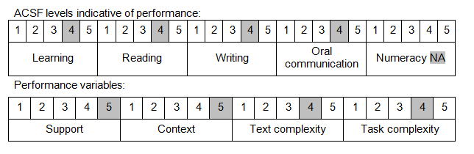
Further information on ACSF and the foundation skills underpinning this unit can be found in the Foundation Skills Guide on the GSA website.

Unit Mapping Information
This unit supersedes and is equivalent to PUAPOLIV004A Conduct investigative interviews.

Links
Companion Volume implementation guides are found in VETNet - https://vetnet.gov.au/Pages/TrainingDocs.aspx?q=98c3984e-2cf1-48a8-8ed1-85e4b92e7351
Companion Volume implementation guides are found in VETNet - https://vetnet.gov.au/Pages/TrainingDocs.aspx?q=98c3984e-2cf1-48a8-8ed1-85e4b92e7351
Companion Volume implementation guides are found in VETNet - https://vetnet.gov.au/Pages/TrainingDocs.aspx?q=98c3984e-2cf1-48a8-8ed1-85e4b92e7351

