POLGEN026 Gather and review information for policing
Release: 1

POLGEN026 Gather and review information for policing

Modification History
Release | Comments
1 | This unit was released in POL Police Training Package release 1.0 and meets the Standards for Training Packages.

Application
This unit describes the skills required to deliver informed policing services and responses, including the gathering, evaluating and exchanging of information.
This unit applies to those working in a policing environment, typically in a general duties role.
The skills and knowledge described in this unit must be applied within the current legislative, regulatory and policy environment in which they are carried out. Organisational policies and procedures must be consulted and adhered to, particularly those related to information security, privacy and codes of conduct.
Those undertaking this unit would primarily work independently or under limited supervision, while performing specific tasks in a broad range of contexts. They would be required to apply decision making and problem solving skills to interpret behaviours and develop solutions.
No licensing, legislative or certification requirements apply to unit at the time of publication.

Competency Field
General

Elements and Performance Criteria
ELEMENTS | PERFORMANCE CRITERIA
Elements describe the essential outcomes | Performance criteria describe the performance needed to demonstrate achievement of the element. Where bold italicised text is used, further information is detailed in the range of conditions section.
1. Gather information | 1.1 Identify internal and external stakeholder needs for information collection and policing purposes.  1.2 Differentiate primary and secondary sources of information for sourcing purposes.  1.3 Collect information from both primary and secondary sources in an ethical and professional manner.  1.4 Organise information to facilitate analysis and referrals.
2. Evaluate information | 2.1 Examine sources of information for potential use within policing.  2.2 Assess information and sources to determine credibility and potential bias.  2.3 Analyse information to identify potential patterns or trends.  2.4 Develop intelligence using information from the local policing area.  2.5 Prioritise information to inform policing service delivery and response.
3. Exchange information | 3.1 Assist in developing intelligence through the identification of potential stakeholder interest.  3.2 Identify communication paths to facilitate information exchange.  3.3 Articulate stakeholder information requirements in support of information exchange.  3.4 Assess information received to establish potential use for policing.

Foundation Skills
The foundation skills demands of this unit have been mapped for alignment with the Australian Core Skills Framework (ACSF). The following tables outline the performance levels indicated for successful attainment of the unit.

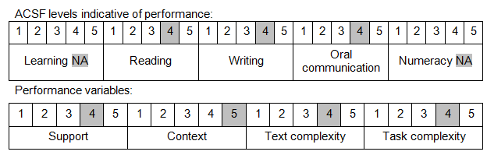

Further information on ACSF and the foundation skills underpinning this unit can be found in the Foundation Skills Guide on the GSA website.

Unit Mapping Information
No equivalent unit.

Links
Companion Volume implementation guides are found in VETNet - https://vetnet.gov.au/Pages/TrainingDocs.aspx?q=98c3984e-2cf1-48a8-8ed1-85e4b92e7351
Companion Volume implementation guides are found in VETNet - https://vetnet.gov.au/Pages/TrainingDocs.aspx?q=98c3984e-2cf1-48a8-8ed1-85e4b92e7351
Companion Volume implementation guides are found in VETNet - https://vetnet.gov.au/Pages/TrainingDocs.aspx?q=98c3984e-2cf1-48a8-8ed1-85e4b92e7351

