POLGEN024 Deliver policing services
Release: 1

POLGEN024 Deliver policing services

Modification History
Release | Comments
1 | This unit was released in POL Police Training Package release 1.0 and meets the Standards for Training Packages.

Application
This unit describes the skills required to deliver policing services, including engaging with individuals and communities, and providing policing services.
This unit applies to those working in a policing environment, typically in a general duties role.
The skills and knowledge described in this unit must be applied within the current legislative, regulatory and policy environment in which they are carried out. Organisational policies and procedures must be consulted and adhered to, particularly those related to codes of ethics and conduct, human rights and anti-discrimination.
Those undertaking this unit would primarily work independently or under limited supervision, while performing complex tasks in a broad range of contexts. They would be required to apply decision making and problem solving skills to interpret behaviours and develop solutions.
No licensing, legislative or certification requirements apply to unit at the time of publication.

Competency Field
General

Elements and Performance Criteria
ELEMENTS | PERFORMANCE CRITERIA
Elements describe the essential outcomes | Performance criteria describe the performance needed to demonstrate achievement of the element. Where bold italicised text is used, further information is detailed in the range of conditions section.
1. Work with individuals/communities | 1.1 Identify individual/community profiles and points of diversity to inform policing services.  1.2 Assess individual/community needs to prioritise policing services.  1.3 Evaluate service delivery options in line with service delivery standards of agency and jurisdictions.  1.4 Identify police service options in support of individuals and community needs.  1.5 Allocate resources to meet the needs of specific individuals/communities.  1.6 Communicate operational status and matters to individuals/communities.  1.7 Respond to feedback from individuals/communities to continually improve policing service delivery.  1.8 Identify special support services available from external stakeholders for referral purposes.
2. Engage with individuals with special needs | 2.1 Assess special needs to inform policing services.  2.2 Identify support options for actioning or referral purposes.  2.3 Provide police services in an ethical manner.
3. Provide policing services | 3.1 Plan engagement activities, taking into account environment and resourcing factors.  3.2 Assess individual/community engagement continually to identify changing needs, constraints and policing service requirements.  3.3 Demonstrate problem-solving/decision making skills when providing policing services.

Foundation Skills
The foundation skills demands of this unit have been mapped for alignment with the Australian Core Skills Framework (ACSF). The following tables outline the performance levels indicated for successful attainment of the unit.
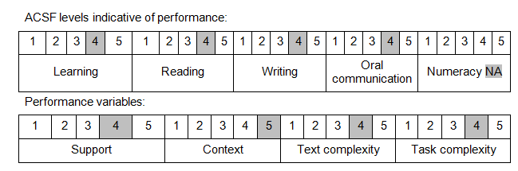

Further information on ACSF and the foundation skills underpinning this unit can be found in the Foundation Skills Guide on the GSA website.

Unit Mapping Information
No equivalent unit.

Links
Companion Volume implementation guides are found in VETNet - https://vetnet.gov.au/Pages/TrainingDocs.aspx?q=98c3984e-2cf1-48a8-8ed1-85e4b92e7351
Companion Volume implementation guides are found in VETNet - https://vetnet.gov.au/Pages/TrainingDocs.aspx?q=98c3984e-2cf1-48a8-8ed1-85e4b92e7351
Companion Volume implementation guides are found in VETNet - https://vetnet.gov.au/Pages/TrainingDocs.aspx?q=98c3984e-2cf1-48a8-8ed1-85e4b92e7351

