POLGEN023 Apply legislation and judicial processes in policing
Release: 1

POLGEN023 Apply legislation and judicial processes in policing

Modification History
Release | Comments
1 | This unit was released in POL Police Training Package release 1.0 and meets the Standards for Training Packages.

Application
This unit describes the skills required to apply current legislation and undertake policing activities within judicial processes. This includes interpreting and applying legislation for policing responses, exercising police powers, preparing judicial documents, collaborating with stakeholders and participating in judicial processes.
This unit applies to those working in a policing environment, typically in a general duties role.
The skills and knowledge described in this unit must be applied within the current legislative, regulatory and policy environment in which they are carried out. Organisational policies and procedures must be consulted and adhered to, particularly those related to police powers, court processes and procedures, and proofs of evidence.
Those undertaking this unit would primarily work autonomously or under limited supervision, while completing complex tasks in a broad range of contexts. They would be required to apply decision making and problem solving skills to interpret behaviours and develop solutions.
No licensing, legislative or certification requirements apply to unit at the time of publication.

Competency Field
General

Elements and Performance Criteria
ELEMENTS | PERFORMANCE CRITERIA
Elements describe the essential outcomes | Performance criteria describe the performance needed to demonstrate achievement of the element. Where bold italicised text is used, further information is detailed in the range of conditions section.
1. Apply legislation for policing purposes | 1.1 Identify sources of legislation for use within policing.  1.2 Demonstrate the connection between legislation and police powers.  1.3 Categorise legislation according to fitness for purpose.  1.4 Apply the Rules of Evidence to the delivery of policing services.  1.5 Differentiate between categories of offences/crimes in terms of their respective elements.
2. Apply legislation related to offences | 2.1 Assess incident/situation to establish whether an offence has been committed.  2.2 Identify relevant sections of legislation applicable to incident/situation to inform policing response.  2.3 Identify potential evidence of offences for charging purposes.
3. Apply legislative powers and cautions | 3.1 Identify legislative sources of police powers to inform policing responses.  3.2 Identify factors that may impact on policing response.  3.3 Exercise police powers in accordance with jurisdictional policies and procedures.  3.4 Deliver relevant cautions and rights in line with police powers, jurisdictional requirements and case law.
4. Prepare judicial documents | 4.1 Assess and document proof of evidence.  4.2 Review judicial documents for compliance purposes.  4.3 Develop briefs of evidence in accordance with the Rules of Evidence.
5. Prepare and work with persons involved in judicial process | 5.1 Determine roles and responsibilities of persons identified to be involved in the judicial process.  5.2 Prepare persons for their involvement in the judicial processes.  5.3 Adhere to the timeframes and governance structures of judicial documents.  5.4 Monitor transport, accommodation and security requirements to facilitate court appearances.  5.5 Identify liaison, care/custody, support and referral requirements of persons involved in the judicial process.
6. Undertake court procedures | 6.1 Dispose of property and exhibits in accordance with legislation and jurisdictional requirements.  6.2 Inform relevant parties of court results.

Foundation Skills
The foundation skills demands of this unit have been mapped for alignment with the Australian Core Skills Framework (ACSF). The following tables outline the performance levels indicated for successful attainment of the unit.

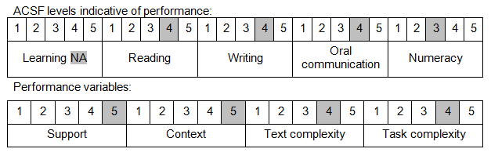

Further information on ACSF and the foundation skills underpinning this unit can be found in the Foundation Skills Guide on the GSA website.

Unit Mapping Information
No equivalent unit.

Links
Companion Volume implementation guides are found in VETNet - https://vetnet.gov.au/Pages/TrainingDocs.aspx?q=98c3984e-2cf1-48a8-8ed1-85e4b92e7351
Companion Volume implementation guides are found in VETNet - https://vetnet.gov.au/Pages/TrainingDocs.aspx?q=98c3984e-2cf1-48a8-8ed1-85e4b92e7351
Companion Volume implementation guides are found in VETNet - https://vetnet.gov.au/Pages/TrainingDocs.aspx?q=98c3984e-2cf1-48a8-8ed1-85e4b92e7351

