POLGEN020 Communicate within a policing environment
Release: 1

POLGEN020 Communicate within a policing environment

Modification History
Release | Comments
1 | This unit was released in POL Police Training Package release 1.0 and meets the Standards for Training Packages.

Application
This unit describes the skills required to communicate effectively in a policing environment, including engaging with audiences, demonstrating relationship building skills, building consensus among stakeholders, using communication options, and using communication equipment. This unit describes the importance of effective communication within policing to ensure public safety, confidence, law and order.
This unit applies to those working within a policing environment.
The skills and knowledge described in this unit must be applied within the current legislative, regulatory and policy environment for policing. Organisational policies and procedures must be consulted and adhered to, particularly those related to codes of ethics and conduct, and anti-discrimination.
Those undertaking this unit generally work independently under mostly indirect supervision. They would perform complex tasks and be required to evaluate and access support from established sources and would show adaptability across a broad range of contexts familiar and/or unpredictable.
No licensing, legislative or certification requirements apply to unit at the time of publication.

Competency Field
General

Elements and Performance Criteria
ELEMENTS | PERFORMANCE CRITERIA
Elements describe the essential outcomes | Performance criteria describe the performance needed to demonstrate achievement of the element. Where bold italicised text is used, further information is detailed in the range of conditions section.
1. Engage target audience | 1.1 Assess information to identify key messages that meet the needs of a target audience.  1.2 Protect the security of information with reference to the risk impact.  1.3 Apply communication techniques to inform a specific target audience.
2. Communicate with influence | 2.1 Evaluate communication options to determine option best suited to a specific community.  2.2 Develop communication options taking into account transparency principles and reputational risk.
3. Build relationships with key stakeholders | 3.1 Identify key stakeholders to initiate and facilitate engagement.  3.2 Initiate relationships with stakeholders to improve policing service delivery.
4. Demonstrate stakeholder management | 4.1 Identify potential conflicts, taking into account stakeholder needs and perceptions.  4.2 Support conflict resolution using conflict handling skills.  4.3 Mediate disputes using negotiation skills.  4.4 Support consensus using liaison skills.

Foundation Skills
The foundation skills demands of this unit have been mapped for alignment with the Australian Core Skills Framework (ACSF). The following tables outline the performance levels indicated for successful attainment of the unit.

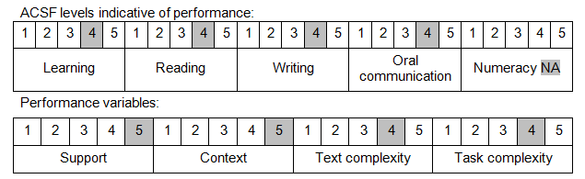

Further information on ACSF and the foundation skills underpinning this unit can be found in the Foundation Skills Guide on the GSA website.

Unit Mapping Information
No equivalent unit.

Links
Companion Volume implementation guides are found in VETNet - https://vetnet.gov.au/Pages/TrainingDocs.aspx?q=98c3984e-2cf1-48a8-8ed1-85e4b92e7351
Companion Volume implementation guides are found in VETNet - https://vetnet.gov.au/Pages/TrainingDocs.aspx?q=98c3984e-2cf1-48a8-8ed1-85e4b92e7351
Companion Volume implementation guides are found in VETNet - https://vetnet.gov.au/Pages/TrainingDocs.aspx?q=98c3984e-2cf1-48a8-8ed1-85e4b92e7351

