POLGEN016 Conduct briefings and debriefings in a policing environment
Release: 1

POLGEN016 Conduct briefings and debriefings in a policing environment

Modification History
Release | Comments
1 | This unit was released in POL Police Training Package release 1.0 and meets the Standards for Training Packages.

Application
This unit describes the skills required to communicate during briefings and debriefings, including the planning, delivery and conclusion aspects of the process.
This unit applies to those working as police staff in operational and non-operational situations within the policing environment.
The skills and knowledge described in this unit must be applied within the legislative, regulatory and policy environment in which they are carried out. Organisational policies and procedures must be consulted and adhered to, particularly those related to information security.
Those undertaking this unit would work both autonomously and within teams as required. They would be required to apply critical thinking and analysis skills to brief and debrief stakeholders within policing. They would demonstrate ethical and professional policing qualities, and show adaptability while performing complex tasks across a broad range of contexts.
No licensing, legislative or certification requirements apply to unit at the time of publication.

Competency Field
General

Elements and Performance Criteria
ELEMENTS | PERFORMANCE CRITERIA
Elements describe the essential outcomes | Performance criteria describe the performance needed to demonstrate achievement of the element. Where bold italicised text is used, further information is detailed in the range of conditions section.
1. Prepare for briefings and debriefings | 1.1 Plan delivery of briefings/debriefings by developing a presentation consistent with the requirements of the policing project.  1.2 Identify clients/stakeholders required to attend briefings/debriefings.  1.3 Identify security level of information and deliver briefings/debriefings accordingly.  1.4 Inform client/stakeholders of briefing/debriefing requirements.
2. Conduct the briefings and debriefings | 2.1 Outline purpose and structure of the briefings/debriefings to clients/stakeholders.  2.2 Present information in line with jurisdictional standards.  2.3 Assess client/stakeholder understanding of briefings/debriefings.  2.4 Adapt communication techniques to facilitate client/stakeholder understanding.  2.5 Encourage contributions from clients/stakeholders to support the effectiveness of the briefings/debriefings.
3. Conclude the briefings and debriefings | 3.1 Respond to feedback/contributions received from client/stakeholder for continuous improvement purposes.  3.2 Record briefing/debriefing outcomes and findings for further actions in line with jurisdictional standards.  3.3 Conduct review of briefings/debriefings to improve own performance.

Foundation Skills
The foundation skills demands of this unit have been mapped for alignment with the Australian Core Skills Framework (ACSF). The following tables outline the performance levels indicated for successful attainment of the unit.

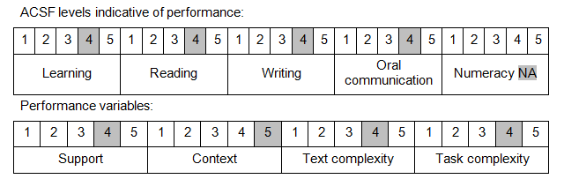

Further information on ACSF and the foundation skills underpinning this unit can be found in the Foundation Skills Guide on the GSA website.

Unit Mapping Information
No equivalent unit.

Links
Companion Volume implementation guides are found in VETNet - https://vetnet.gov.au/Pages/TrainingDocs.aspx?q=98c3984e-2cf1-48a8-8ed1-85e4b92e7351
Companion Volume implementation guides are found in VETNet - https://vetnet.gov.au/Pages/TrainingDocs.aspx?q=98c3984e-2cf1-48a8-8ed1-85e4b92e7351
Companion Volume implementation guides are found in VETNet - https://vetnet.gov.au/Pages/TrainingDocs.aspx?q=98c3984e-2cf1-48a8-8ed1-85e4b92e7351

