POLGEN014 Minimise hazards in a policing environment
Release: 1

POLGEN014 Minimise hazards in a policing environment

Modification History
Release | Comments
1 | This unit was released in POL Police Training Package release 1.0 and meets the Standards for Training Packages.

Application
This unit describes the skills required to maintain safety in a policing environment, including the proper use of personal protective equipment and control of hazards.
This unit applies to those working as police members operating within a policing environment.
The skills and knowledge described in this unit must be applied within the legislative, regulatory and policy environment in which they are carried out. Organisational policies and procedures must be consulted and adhered to, particularly those relating to information security and codes of conduct.
Those undertaking this unit would work independently or under supervision with responsibility for their own functions and outputs. They would undertake specific tasks within established parameters and would develop solutions in mostly predictable contexts.
No licensing, legislative or certification requirements apply to unit at the time of publication.

Competency Field
General

Elements and Performance Criteria
ELEMENTS | PERFORMANCE CRITERIA
Elements describe the essential outcomes | Performance criteria describe the performance needed to demonstrate achievement of the element. Where bold italicised text is used, further information is detailed in the range of conditions section.
1. Respond to hazards | 1.1 Identify hazards in work environment for reporting purposes.  1.2 Report hazards to designated personnel in accordance with workplace procedures.  1.3 Maintain own safety within workplace.  1.4 Follow instructions to control risks.
2. Use personal protective equipment | 2.1 Assess situation to identify personal protective equipment requirements.  2.2 Select personal protective equipment to protect safety of self.  2.3 Use personal protective equipment to protect safety of self.  2.4 Replace personal protective equipment in accordance with operational requirements.

Foundation Skills
The foundation skills demands of this unit have been mapped for alignment with the Australian Core Skills Framework (ACSF). The following tables outline the performance levels indicated for successful attainment of the unit.

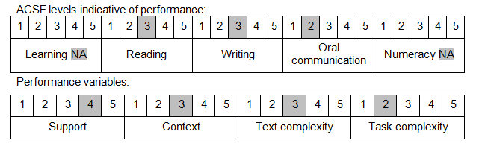

Further information on ACSF and the foundation skills underpinning this unit can be found in the Foundation Skills Guide on the GSA website.

Unit Mapping Information
No equivalent unit.

Links
Companion Volume implementation guides are found in VETNet - https://vetnet.gov.au/Pages/TrainingDocs.aspx?q=98c3984e-2cf1-48a8-8ed1-85e4b92e7351
Companion Volume implementation guides are found in VETNet - https://vetnet.gov.au/Pages/TrainingDocs.aspx?q=98c3984e-2cf1-48a8-8ed1-85e4b92e7351
Companion Volume implementation guides are found in VETNet - https://vetnet.gov.au/Pages/TrainingDocs.aspx?q=98c3984e-2cf1-48a8-8ed1-85e4b92e7351

