POLGEN007 Review policing governance and accountability compliance
Release: 1

POLGEN007 Review policing governance and accountability compliance

Modification History
Release | Comments
1 | This unit was released in POL Police Training Package release 1.0 and meets the Standards for Training Packages.  This unit supersedes and is equivalent to PUAPOL804 Manage an internal compliance audit and review within policing.  - Content and formatting updated to comply with new standards  - Unit recoded POL  - Title updated  - Element 2 all PC revised

Application
This unit describes the skills required to oversee internal compliance audits and reviews, including planning, monitoring and concluding activities.
This unit applies to police managers and forms part of their responsibilities within policing hierarchies related to police legitimacy and transparency, in both a public service and public safety context.
The skills and knowledge described in this unit must be applied within the legislative, regulatory and policy environment in which they are carried out. Organisational policies and procedures must be consulted and adhered to, particularly those related to privacy and police legitimacy.
Those undertaking this role would demonstrate strong autonomy, making strategic decisions and providing leadership to the jurisdiction supervising teams in a broad range of contexts while performing sophisticated tasks. They would provide advice and influence executive decisions for stakeholders while performing complex tasks in a range of contexts.
No licensing, legislative or certification requirements apply to unit at the time of publication.

Competency Field
General

Elements and Performance Criteria
ELEMENTS | PERFORMANCE CRITERIA
Elements describe the essential outcomes | Performance criteria describe the performance needed to demonstrate achievement of the element. Where bold italicised text is used, further information is detailed in the range of conditions section.
1. Plan internal compliance audit/review | 1.1 Assess the business activity and/or information from stakeholders to inform the scope and objectives of the audit/review.  1.2 Define scope and objectives of audit/review.  1.3 Design the compliance audit/review, including method, roles and responsibilities.  1.4 Evaluate audit/review plan to ensure it meets objectives and jurisdictional expectations.  1.5 Identify potential sources of information/intelligence to inform audit/review.
2. Conduct internal compliance audit/review | 2.1 Communicate the objectives, scope, roles and responsibilities of the audit/review to audit/review team and stakeholders.  2.2 Collect information/intelligence to facilitate audit/review.  2.3 Analyse information collected to determine its relevance as audit/review evidence.  2.4 Analyse audit/review evidence to identify levels of compliance and areas for improvement.  2.5 Develop preliminary audit/review findings and recommendations through evaluation of audit/review evidence.
3. Monitor internal compliance audit/review | 3.1 Monitor the progress of the audit/review to determine whether any adjustments are required.  3.2 Conduct environmental scans to ensure contemporary nature and validity of audit/review.  3.3 Monitor the integrity of the audit/review to ensure audit/review outcomes are reached.  3.4 Manage audit/review progress in line with governance and accountability requirements.
4. Conclude internal compliance audit/review | 4.1 Evaluate preliminary audit/review findings and recommendations to determine how and what should be communicated to stakeholders.  4.2 Assess findings and develop recommendations to ensure compliance/improvements.  4.3 Review own performance throughout the audit/review process using stakeholder feedback.  4.4 Assess the audit/review process to inform future practice.

Foundation Skills
The foundation skills demands of this unit have been mapped for alignment with the Australian Core Skills Framework (ACSF). The following tables outline the performance levels indicated for successful attainment of the unit.

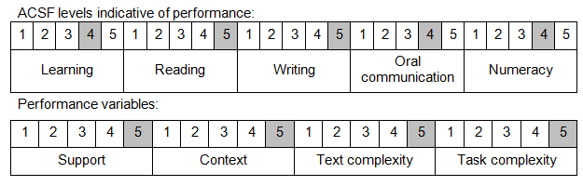

Further information on ACSF and the foundation skills underpinning this unit can be found in the Foundation Skills Guide on the GSA website.

Unit Mapping Information
This unit supersedes and is equivalent to PUAPOL804 Manage an internal compliance audit and review within policing.

Links
Companion Volume implementation guides are found in VETNet - https://vetnet.gov.au/Pages/TrainingDocs.aspx?q=98c3984e-2cf1-48a8-8ed1-85e4b92e7351
Companion Volume implementation guides are found in VETNet - https://vetnet.gov.au/Pages/TrainingDocs.aspx?q=98c3984e-2cf1-48a8-8ed1-85e4b92e7351
Companion Volume implementation guides are found in VETNet - https://vetnet.gov.au/Pages/TrainingDocs.aspx?q=98c3984e-2cf1-48a8-8ed1-85e4b92e7351

